الله كا مهمان

GUEST OF ALLAH
(A Hajj Guide)
By

Rasheed Ahmad Siddiqui

INDEX
S no. Topic Page No.

Certificate of Authenticity
- How to Apply for Hajj
- Issues Related with Hajj
- Duties Towards Fellow Humans & Renunciation
- Medical Tips
- Important things to know
- Necessary precautions
- A Lifelong Charity
- Chronicals from the Prophet’s words
- Mak`kah and the sanctified House of Allah
- The Prophet’s edict about Ka`abah
- The Excellence of Black stone
- Some sayings of the Prophet about Hajj
- Hajj, The obligatory Pillar of Islam
- Kinds of Hajj
- (A)Hajj-e-Ifrad (B) Hajj-e-Tamattu (C) Hajj-e-Qiran
- Hajj-e-Badal/Substitute Hajj
- Explanation of terms used in Hajj Pilgrimage
- The Holy Places in and around Mak`kah
- Talbiyah
- Rewards of saying prayer in Masjid-e-Haram
- Prohibited times of prayer
- Congregational prayer on Radio’s broadcast
- Some rules/Etiquettes about prayer
- Pass by from the front of one saying prayer
- Abbreviated version of prayer (Qasar)
- Ihram of a Minor
- All About Ihram
- Issues Related with Ihram
- Janayat:
- Doing things against restrictions
- When animal sacrifice (Dum) falls due
- (A) Use of Perfume (B) Use of stitched cloths
- (C) Covering the Head & Face , Shaving & Hair cut
- (D) Cutting of nails (E) Sexual Relations
- Badna; slaughtering of one full cow or camel
- An unlawful act due to some reason
- About Women;
- (A) Mahram is must for women’s travel
- (B) Who is Marham (C) Ihram of Ladies (D) Veil for Ladies
- (E) Observance of Pardha while in Ahram
- (F) Miscellaneous issues and propositions
- (G) Women not allowed to mingle with men
- Circumambulation (Tawaf)
- (A) The Excellence of Tawaf
- (B) Kinds of Tawaf (C) Rules and Etiquettes of Tawaf
- Meeqat
- Ehram for travelers by air
- Umrah
- (A)Preparation for Umrah
- (B)The Niyah of Umrah
- (C)Departure from Home
- (D)Prayer on Disembarkation
- (E)Entering Mak`kah and The Holy Mosque
- (F)The first glance on Ka`abah & Iztiba
- (G)Umrah (step by step)
- Multazim & Zam-Zam water
- Two unit salat after Tawaf
- Saee
- Issues related with Saee
- Halaq & Qasar and their rules
- Taneem
- Invocations in Tawaf
- Some useful invocations
- The Hajj
- The rites of Greater Pilgrimage
- Three Pillars of Hajj and Duties (Wajibat)
- How to perform Hajj (Rules & Etiquettes) 1st day of Hajj
- The day of Arafah; 9th ZilHijj-2nd day of Hajj
- How to offer Mid-day and afternoon Prayers in Arafat
- The Excellence of Arafat
- Invocation and prayer in Arafat
- Rules and Etiquettes of Waqoof and Waqoof-e-Arafat
- Afternoon in Arafat (Asar) and Departure for Muzdalfa
- 10th ZilHijj ; 3rd day of Hajj
- Invocation for animal sacrifice/Immolation
- And after Immolation/sacrifice
- 10th ZilHajj (continued)
- Tawaf-e-Ziarat (Tawaf-e-Ifada) and rules thereof.
- Saee after Tawaf-e-Ziarat
- 11th ZilHajj (4th day of Hajj) ; Rami
- 12th ZilHajj (5th day of Hajj)
- Farewell Circumambulation (Tawaf-e-Wida)
- Prayer of Prophet Ibrahim (PBUH)
- Journey to Madinah ; Guest of Prophet (PBUH)
- Preparations before proceeding to Madina
- Pilgrim to Prophet’s Tomb and its excellence
- Not coming at the tomb of Prophet
- The excellence of reciting Darood
- Not reciting Darood for Prophet: Consequences
- Where it is desirable to offer Darood
- Etiquette of visiting Madinah
- In Madinah-al-Munawwara
- Visit to Prophet’s Mosque
- Pillars of blessing in Garden of Paradise
- Invocation
- Fourty prayers in Prophet’s Mosque
- The Holy Places to be visited
- Return from Madinah
- From Madinah to Mak’kah or Jeddah.

In the name of Allah, Most Beneficent Most Merciful
Praise be to Allah, the Supreme Being and peace and blessing of Allah upon the noblest of the Prophet and Messenger of God, our Prophet Muhammad Bin Abdullah (PBUH).
This guide to Hajj has been compiled by me for English speaking Muslims to facilitate the performance of Hajj and its rituals. It was nothing less than Divine guidance and in submission to his will that showed me the way and who I hope will condone my lapses on Day of Reckoning. I shall also feel richly rewarded of if my humble effort becomes of some benefit to the intending Hajis that may become a source of salvation for me and allow me to stand with those who will solicit the Holy Prophet’s (PBUH) intercession on the Day of Judgment.
The task was rather difficult for a sinner like me but nothing less than the grace of God and His guidance that I could accomplish it. And I beseech to Allah that those who helped me in the compilation of this guide may also be suitably reward by Allah the most merciful their’s and their parent’s sins and transgressions be forgiven.
My Lord forgive me and brings all of us into Thy mercy on the day of Resurrection. Ameen .
An humble servant of God and His Prophet
(Rasheed Ahmad Siddiqui)

Translator’s submission
This guide to Hajj & Umrah is the faithful translation of Urdu version of “Allah ke Mehman” and “Prophet’s Mehman”. It was a difficult assignment for a sinner like me to translate a religious guide in a manner as to maintain its original perception. Being an spiritual and an invigorating work I felt an inexplicable urge to accomplish it, though for that I had to refer several religious works in search of appropriate words and phrases, especially for Ahadith.
Conscious of my limitations, I accept my shortcomings and mistakes and pray to Allah to condone my lapses. Some religious words have been adopted in their original associated with or without translation as they comprehend within them the correct perception.
I hope this English version of “Allah ke Mehman” shall be helpful in the performance of Hajj and Umrah by the English speaking Muslims in Europe and America.
Farid Uddin Ahmad

Certificate of Autheriticity
From
Mufti Muhammad Yosuf Ludhianawi (Late)
In the name of Allah, Most Beneficent, Most Merciful
The last and the fifth cardinal doctrine of Islam is the performance of Hajj which forms the completion of Islamic obligations. It is an spiritual journey demanding total sacrifice of personal comforts and pleasures. It is accompanied with bounties, blessings and salvation at every step and breath.
In the institution of Hajj, God the Almighty has promised His innumerable rewards against each act of goodness and virtue. Yet for any smallest act of impudence one may be deprived of the rewards promised by Allah. It is why a pilgrim has to take extreme care on every step in performance of the rituals associated with Hajj. Likewise those who intend to provide assistance or facilitate Hajjis in their performance of Hajj have to be equally careful in describing and explaining the rules and etiquettes associated with it. Any laps towards this shall be counted as sin.
This guide for Hajj pilgrims has been compiled by Al-Haj Rasheed Ahmad Siddiqui, a grandson of Maulana Muhammad Ahmad, a notable compiler of “Dars-e-Qur`an” in most lucid way. It describes all the requirements and acts that an Hajji has to perform in the fulfillment of the rituals.
My colleague Maulana Mufti Izhar Ahmad Bakshi has carefully vetted the script and found it reliable and useful. My prayer is for the screen of the compiler and all those associated with the project.

How to Apply for Hajj
There are two types of Hajj travel facilities available in Pakistan:
(A) Government Scheme (B) Private Scheme
(A) Government Scheme
- As a normal practice, Govt. of Pakistan’s Ministry of Hajj & Auqaf invites applications for Hajj through banks a few months before. If you have the intention to perform Hajj, submit your application as per rules. Make sure that “Niyah” or the intention avowed by a would-be-pilgrim is considered the most essential ingredient in a individual’s commitment to make the pilgrimage. That one has no intention to make the journey a joy ride or a business trip.
The vow taken serenely in private is what gives the pilgrimage that will follow the true impact. It is the vow that underlines the meaning of the cry “Labbayak”. I am with Thee or Here I am in Thy presence.
- If you intend to proceed for Hajj in a particular group then all the applications of that group should be submitted together. In other case the bank authorities shall form the group at their own discretion.
- Those who apply in group shall travel by air or by bus together. Their Maktab and Maullim in Saudi Arabia, shall be same. They will stay all at one place.
- Some pilgrims do not intend to avail the accommodation facility arranged by the government. Such person should submit a certificate in this respect from Saudi authorities in Mak’kah to the bank concerned. Accommodation charges shall be refunded in due course of time.
- All intending Hajis are well advised to strictly follow the custom regulations of both Saudi and Pakistani govt. Articles like knife, toothpaste, tooth powder, soap, eatable like sweets, biscuits, sugar, flour, video/audio cassettes or computer disks are totally disallowed. If found in your luggage shall be confiscated at the airport. Do not carry starched cloths. Saudi authorities suspect this to be dipped in narcotic with severe punishment if detected.
- Intending Haji should submit photographs, preferably coloured in size and number as mentioned in the application form. Also keep a few photographs with you in spare.
- Keep the official receipt issued by the bank very carefully. Every Haji shall have to present this receipt while taking delivery of the passport, foreign exchange, medical certificate etc. Every Haji should give the name, NIC number and the address of his/her next of kin.
(B) Private Scheme
- Those Hajis who intend to avail the private Hajj facility should very carefully select their Hajj group. The group organizers should have the registration with Ministry of Religious Affairs, Government of Pakistan and should have good reputation amongst the circle of Hajis who have availed their services in the past.

To learn the issue related with Hajj
Having submitted the application for Hajj an intending Haji should familiarise and try to know each and every thing, worldly or abstract, related to the performance of the pilgrimage. For example:
- Ablution (Wozo). All acts related with it.
- Call to Prayer (Azan) and call to lineup (Aqamat). Offering of Salat
- Abbreviated version of Prayer (Salat)
- Ladies must know the etiquette of entering the mosque.
- Ladies must know all steps of offering prayer in the Holy Mosques behind a prayer leader, in congregation, and especially about Friday noon prayer.
- Funeral prayer and invocations (Dua) related with it.
- Recitation of the Holy Quran with corrects pronunciation and phonetics.
- All pilgrims must learn some portion of the Holy Quran , specially the last 20 verses (Surah) from the 30th chapter of Qur’an.
- They should remember by heart different invocations appropriate for different occasions as proved by Hadiths regarding Hajj.
- They should know Talbiyah (the formula prayer) besides the four “Kalamas”.
- If the intending Haji is a borrower of anything including the money, that should be returned. He should be with minimum possible liabilities. He should also write down his will and deposit it with some trustworthy relative.
- He should make farewell calls to all his relations and friends and seek their forgiveness.

Duties towards Fellow Humans

Every Haji should know and understand his duties owed to God (Huqooq Allah), his duties and responsibilities towards fellow human beings (Huqooq-ul-Ibad). God forgives things which is owed to him by his servants, if He please, provided the sinner repents and affirms not to repeat such acts. But in case of wrong done to other people God does not forgive unless the offender pays back to the aggrieved and the wronged person forgive.

Therefore, every Haji should be careful enough not to hurt any other person and should bear with patience minor mistakes or wrongs. Although, man being fallible it is inevitable to see sharp exchanges even in Makkah. Yet the pilgrim should try to contain himself and exhibit forbearance.

Renunciation
If any mistake or a forbidden act in committed by a Muslim, he should return to God at the earliest for repentance. He should do some act of piety or offer two “Rakat” optional prayer and seek His forgiveness with all sincerely and from the depth of his heart.
He should repeat countless of time “Kalma-e-Tayyaba” and try to keep himself aloof from acts of sin. It is stated in Hadith that one who recite Kalma-e-Tayabba with sincerity and devotion, he is sure to be honoured by God the Merciful. This will protect him from lapses and shortcomings.

Medical Tips

Preparation for the Hajj is long and ardous undertaking. Every Haji need to be acquainted with medical, administrative and travel formalities. It is wise to start preparation from the month of Ramzan.

The pilgrim should start with inoculation against “Meningitis” and “Typhoid” about 15 to 10 days before the commencement of journey. Certificate of the inoculation should be kept safely otherwise Saudi authorities at Jeddah airport shall put the Haji in quarantine.

Pilgrim should also carry with them essential medicines for any particular ailment like Diabetis, Blood pressure, Heart problems, Arthritis etc. He should present all the medicines, in packed form duly supported by medical prescription, to medical officer at Haji camp. The medical officer shall put his signature and seal the plastic bag. Saudi authorities does not allow loose and uncertified medicines.

Important Things to know
- Every pilgrim should have well acquaintance with his group leader and other members of the group.
- Essential items to be carried by an Haji are :-
At least
- 2 sets of Ihram, enough clothes,
- 2 pairs of sandals, that can leave the heal and the toes uncovered,
- One cake each of plain and scented soap,
- Scarf for ladies,
- Towel,
- Toothbrush and paste, Miswak (if one use it),
- Comb,
- A few safety pins,
- Needle and thread,
- An small mirror,
- A marker,
- A few plates with spoons,
- Thermos, flask,
- Nail cutter,
- Plastic adhesive tape,
- Ihram belt,
- Small scissor,
- Two small coils of thin nylon rope,
- Those who use spectacles should carry an spare spectacle,
- A pair of good quality and comfortable shoes.
Efforts should be made to carry only essential items to keep one as light as possible in accompanying luggage.
- Ladies should always be in decent but proper dress. They should avoid wearing thin and gorgeous dresses. They should be careful about veil and always use “Abaya” when going out.
- Accompanying luggage should be properly secured. One may have to carry his luggage. Only 30-kg weight is allowed to air passengers.
- Always put your identification mark on all items of your luggage, like sticker issued by the group leader or hand written address properly pasted. The sticker should bear, beside your own name, the name of the Muallim & No. of Maktab, Group number etc., so that in case of misplacement, it could be traced quickly.
- If a pilgrim is carrying Travelers Cheque, he should leave behind photocopies of these cheques so that in case of loss or theft, claim could be lodged easily.
- Do not encash all the travelers cheque at one time. Encash them as and when the money is needed. In case of loss of these cheques the report should immediately be lodged with Pakistan mission and with the bank. After necessary verification the bank will either issue the duplicate cheque or the equal amount.
- Do not try to honour too many requests from friends or relatives. In the cumulative way you will be burdened with weight and the limited amount of foreign currency may fall short.

Necessary Precautions
- Always keep in mind that you are on a noble and spiritual journey the spirit of which rests on the absolute belief in God’s unity, sincerity of intention, obedience to God and to His Prophet (PBUH).
- Avoid disputes and altercation and disobedience to God.
- God, the Almighty has prescribed the ritual duties according to their degree of importance. Some are obligatory in nature while others are Traditional and Desirable (Mustahab). In Hajj rituals like kissing the Black-Stone (Hajar-e-Aswad) offering prayer at the place of Abraham, drinking water of Zam-Zam at the well or taps fall in the degree of Traditional or Desirable and one should perform them with patience and restitute without disturbing or pushing other men or women. It is forbidden to hurt any believer in Haram.
- During the Hajj season there is always milling crowd in Haram, especially around Ka`bah. In such condition one should avoid sitting close to Ka’bah or in Mutaf, offering prayer at or near the white strip denoting the line of Black-Stone. That may create obstacles for others in the performance of their rituals.
- Wile passing from Yemenite Angle (Rukan-e-Yamani) say “Bismillah” Allah-o-Akbar and simply touch it with right hand. There is no dogmatic requirement to kiss it. If crowed does not permit even this touch then simply keep moving in circumambulating (Tawaf) without gesturing towards Yemenite Angle.
- One should not sit or offer prayer in walkways or passages in Haram. This will cause trouble to others.
- Ladies should avoid wearing glass bangles in Haram which often break in crowed. Glass pieces on the floor can injure the barefooted Hajis.

A lifelong Charity
Al-Hamdo-Lillah: This organization Al-Rasheed Foundation is helping the prospective Hajis, since 1997, from submission of the Hajj application to departure and performance of all the Hajj rituals successfully. It also holds training sessions for the benefit and of intending pilgrims. It has also published several books on Islam. The foundation shall welcome every individual contributing his mite in this lifelong charity.

Good News for Intending Hajis
The Messenger of God said:
- “As you embark on a journey for Hajj, on every step of yours God bestow you with one act of goodness and is pardoned with one sin.”
- “As one offers two Rakat prayer after circumambulation, God the merciful reward the well-doers as if one has freed a slave. And running between As-Safa and Al-Marwah in Saee is just equal to freeing 70 slaves.”
- “And when all the Hajis have assembled in the plain of Arafat, God the Blessed and Exalted descends to that part of the heaven closest to earth and say to the Archangels, pointing towards the Hajis, “Behold my servants” they have come to me in bad condition, covered with dust and burnt by sun. They have come from the far corners of the earth to seek my mercy. I pardon them all even if their sins have no limit. Go my obedient servants, you have been pardoned in advance and also the sins of those whom you name on this day.”
- “Then he said; “When a pilgrim stones a pillar in Mina, God the Merciful pardons one great sin of his for each pebble.”
- “And the reward of immolation, you will get in Hereafter”
- “And when a pilgrim get his head shaved before coming out of Ihram, he is rewarded with one virtue for each hair.”
- “And when the Haji performs (Tawaf-e-Ifadah) he becomes absolutely free from sins and an archangel tell him to go for good conduct since God has pardoned all your past sins.”

Makkah and The Sanctified House of Allah (The Ka`abah)
The Holy Qur`an says about Makkah and Ka`abah:-
- “Lo; the first sanctuary appointed for mankind was that Makkah, a blessed place, a guidance to the people. Where in are plain memorials; the place where Abraham stood up to pray and whosoever entereth it is safe. And pilgrimage to the House is a duty unto Allah for mankind for him who can find a way thither.” (Al-Imran; 96-97)
- “And remember when We prepared for Abraham the place of the (Holy) House, saying: Ascribe thou nothing as partner unto Me and purify my House for those who make the round and those who stand and those who bow and make prostration (Al-Hajj : 26)

Prophet Muhammad’s (PBUH) edict about Ka`abah
- “On the day of resurrection, the Holy Ka`abah shall be lifted like a bride and all those who has visited and prayed in it shall be in company with it and shall enter the paradise.”
- Hasan basri reported form Hazrat Ali (RDA) that keeping one fast in Makkah is good as hundred thousand fasts elsewhere. Offering one Dirham as alm to someone in Makkah is equal to offering hundred thousand Dirhams in charity elsewhere. Similarly an act of virtue or piety is equal to hundred thousand virtues.
- It is reported that on every night when God the Almighty looks to his creatures on this earth, his first gaze falls on Makkah (The Haram) and in particular on those in Ka`abah busy in praying and in invocation. God in His mercy blesses them.
- Ibn-e-Abbas reported that “at the time of conquest of Makkah the Apostle of Allah (PBUH) addressing the Baitullah said; “O Makkah, how good art thou among the cities and how dear art thou to me. Had not my people driven me out of thee, I would not have resided elsewhere (Tirmizi).
- Abdullah-Ibn-e-Masood reported that there is no city or place on earth except Makkah where man is accountable for Niyah and action. That is why it is said that while every piety or virtue is rewarded here innumerably, every sin is also punished severely.

The Excellence of Black stone
The Black stone (Hajr-e-Aswad) is an oval shaped stone about 18 centimeters in diameter. It rests within a mesh of silver wire to prevent it from crumbling. It is set in the angle of Ka`abah which is between the sides known as Multzim and the Yemenite angle.
The origin of this stone is not clear According to one version it was the Archangel Jibreel (Gabriel) who brought it for Adam from Paradise. The first man then kept it and transmitted it after the Deluge to Noah’s descendents, which is how it came into Abraham’s hand.
Prophet Muhammad (PBUH) said about the Black Stone that it is a jewel from Paradise. On the day of Resurrection it will be lifted to Heaven with two eyes and tongue. It will be testifying about every human who has kissed it. The Prophet (PBUH) used to kiss it abundantly. It is also reported that Prophet (PBUH) bowed before it in prostration.
Abu Tufail reported: I saw Apostle of Allah going round the House and, while riding on camel back, used to touch the stone by an stick and kissing the tip of the stick.
It is also reported that when Adam was sent down to earth from Paradise, he feared Satan and beseeched protection from Allah who ordered Archangels to stand around Ka`abah to protect Adam. Thus all the space around Ka`abah ringed by angels was declared as “Haram”.
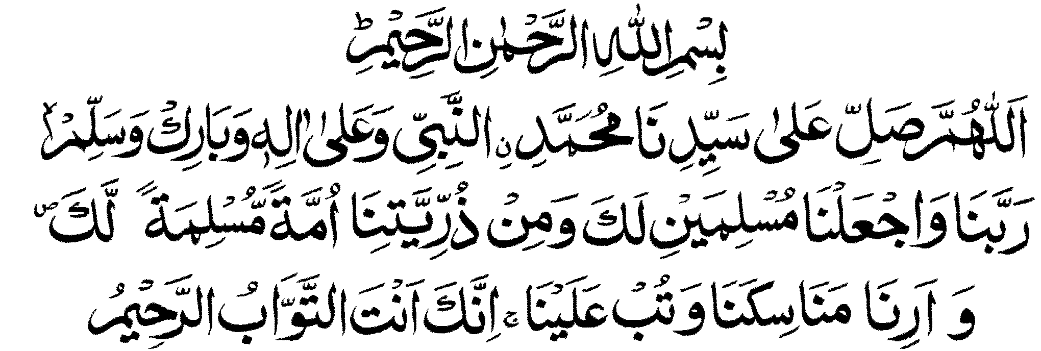
According to another saying, when Prophet Abraham (PBUH) fixed the Black Stone into Ka`abah all those places that received light rays emanating from the stone were declared part of the Haram.

To go on the pilgrimage (Hajj) to the House of God is one of the five fundamentals of Islam and is obligatory on every Muslim whosoever is able to accomplish it. The Holy Quran and Hadiths have repeatedly stressed about it as being obligatory and important.
Al-Quran says:-
- “And proclaim unto mankind the pilgrimage. They will come unto thee on foot and on every lean camel; they will come from every deep ravine” (Al-Hajj : 27)
- “And pilgrimage to the House is a duty unto Allah for mankind, for him who can find a way thither. As for him who disbelievsth, lo; Allah is independent of creatures.” (Al-Imran : 97)

Some saying of the Prophet (PBUH) about Hajj
- Abu Hurairah reported that the Messenger of Allah was asked: what action is most commendable? He said: faith in Allah and His Messenger. He was asked what is next? He said: Jihad in the way of Allah. He was asked; what is next? He said Hajj, which is accepted. (Bukhari-2391)
- Abu Hurairah reported that the Messenger of Allah has said, “whosoever performs the Hajj for the sake of Allah without talking immodestly or acting wickedly, he returns (free from sins) as on the day his mother gave him birth.” (Bukhari : 2393/3)
- Abu Hurairah reported that the Messenger of Allah has said, “an Umrah is an expiation for sins committed between it and the next, but a Hajj which is accepted has no less a reward than Paradise.” (Bukhari : 2394/4)
- Ibn-e-Abbas reported that the Messenger of Allah has said, “an Umrah in Ramzan is equal to Hajj.” (Bukhari : 23959/5)
- Ibn-e-Abbas reported that a man came to the Holy Prophet and said: My sister had made a vow to perform Hajj, but she died. The Holy prophet asked; would you pay a debt supposing she owed one? He said; yes. The Holy Prophet said “ well pay the debt due to Allah, because it is the one which most deserves to be paid.” (Bukhari : 2398/8)
- Hazrat Aa`isha (RDA) reported: I saught the Holy Prophet’s permission to take part in Jihad. He said, “The Jihad of you women is the Hajj.” (Bukhari : 2400/10)

- Hazrat Ali (RDA) reported that the Messenger of Allah said; “one who possess means of food and other expenses including conveyance, yet he eludes Hajj; he shall die as Jew or Christian because God Almighty has ordained Hajj as obligatory for one who can afford. (Tirmizi).
- Ibn-e-Abbas reported that the Messenger of Allah said; “one who forsake Hajj and Nikah is not from among us.”
- Ibn-e-Abbas reported that the Messenger of Allah has said; “whoever intends to perform the Hajj he should hasten to do so.” (Abu Dawood 2409/19)
- Hazrat Ibn-e-Masood (RDA) reported that the Messenger of Allah has said; “make Hajj and Umrah follow one another closely because they remove poverty and sins as cauldron removes impurities from iron, gold and silver and a Hajj which is accepted gets no less reward than paradise.” (Tirmizi)
- Hazrat Abu Hurairah (RDA) reported that the Holy Prophet said; “those who perform the Hajj and those who perform Umrah are the guest of Allah. If they supplicate Him, He responds to them and if they seek Him forgiveness, He forgives them.” (Ibn-e-Maja)
- Hazrat Ibn-e-Umar (RDA) reported that a man asked the Prophet of Allah: what is the description of a pilgrim? He said; “disheveled and unperfumed.” Another got up and asked; O Messenger of Allah which part of the Hajj is most beneficial? He said; “raising the voice in Talbiyah and shedding the blood of sacrificial animal.” Another got up and asked; O Messenger of Allah, what is meant of Sabeel? He said; “Provision and means of conveyance.”
- Hazrat Ibn-e-Abbas reported that the Messenger of Allah heard a man saying “Labbaik on behalf of Shubrumah.” He asked: who is Shubrumah? The man replied, a brother of mine or a relative of mine. He asked; “Have you performed the Hajj on your own behalf?” He replied: No. The Prophet said, “perform the Hajj on your behalf, then perform it on behalf of Shubramah.” (Ibn-e-Maja, Abu Dawood)
- Hazrat Abu Hurairah (RDA) reported: I heard the Messenger of Allah say, “the guest of Allah are three: the warrior, the one who performs the Hajj and the one who performs the Umrah.
- Hazrat Ibn-e-Umar (RDA) reported that the Messenger of Allah has said; “when you meet one who has performed the Hajj, greet him, shake hands with him and tell him to ask forgiveness for you before he enters his house because he has been forgiven by Allah.” (Ahmad : 2423/33)
- Hazrat Abu Hurairah (RDA) reported from the Messenger of Allah that “whoever goes out to perform Hajj, Umrah or Jihad but died on the way, Allah grant him the reward of Hajj, Umrah or Jihad.”

Hajj; an Obligatory Pillar of Islam
The pilgrimage of Hajj is compulsory in the life-time of every adult Muslim, man or woman who is in a position to undertake the journey in accordance with the Divine proclamation. But before going to Mak`kah a certain number of conditions must be met:
- One must be Muslim.
- One must be in a position to pay for the cost of journey and the expenses of stay, as well as for the upkeep of one’s family, back home, during his absence with money earned by honest means.
- There should be peace and tranquility in way to pilgrimage.
- One must be in a sound physical and material position to accomplish the pilgrimage.
- One must be of sound mind and in full possession of one’s mental faculties.
- One must have reached puberty.
- It should be the appropriate time for Hajj.
With above conditions fulfilled, the Hajj becomes an obligation and the pilgrimage to the House becomes a duty towards God. One who accomplishes this duty is rewarded, while one who gives it up is sinner and shall be punished while one who refutes its obligatory nature is an infidel before Allah. The Holy Prophet (PBUH) also declared: “God has prescribed unto you a pilgrimage, therefore accomplish it.”
There is a notion among some people that if a young girl in the family is awaiting marriage, the obligation of Hajj is not applicable. There are no basis of this notion and it is false.
Some people of means think that it is the parents who should perform Hajj before them. This is incorrect. If they have the means to support their family members including children, they should go all including the parents. A male member should not delay his pilgrimage, if he has the means, to wait for the accumulation of so much means as to include other members of the family.
One who has acquired the means should not delay the pilgrimage. If case the died he will be a sinner.
Pilgrimage becomes compulsory for a woman, too, who have her own means to meet the expenses of self and her Mahram that may be father, son, brother or husband. A trusted woman friend can also accompany even if she not a relative.

بسم الله الرحمن الرحيم
الحج الحج الحج
Kinds of Hajj
The rites of Hajj pilgrimage fall into three categories:
- Al-Ifrad
- Tamattu
- Qir`an

Al-Ifrad
If one intend to perform only Hajj but not Umrah it is called Al-Ifrad. Those who live within the limits of Haram or within Meeqats, can perform Hajj-e-Ifrad. Even those living in Jeddah can also perform Hajj-e-Ifrad. In this category of Hajj one has to enter into Ihram with the intent of Hajj only but without Umrah. They should not perform Umrah during the Hajj season.
Ever those living outside the Meeqats or limits of Haram (much known as Afaqis) can also perform Hajj in this category. This is known as “Mufrad” wherein animal sacrifice is not obligatory.

The Niyah or Intent
The Niyah or intent for Hajj is: -
“O Allah, I intend to perform Hajj. Make thou the same easy for me and accept it from me. I have conceived the Niyyat for Hajj and I have adopted the Ihram sincerely for Allah.”
A pilgrim has to accomplish the following in Hajj-e-Ifrad:
- Ihram---- a sacred state. Compulsory.
- Tawaf Qudoom. It is a Sunnah of the Prophet (PBUH).
- Waqoof or stay at Arafat ----- An essential (Rukun).
- Waqoof at Muzdalfa----- Duty or obligatory (Wajib).
- Stoning of Jamrah-e-Al-Aqabah (The greater Satan) Duty or obligatory.
- Animal Sacrifice or Immolation----- optional.
- Shaving of Head----- Duty or obligation (Wajib).
- Tawaf-e-Ziarat (Ifadah)------ Essential / Fundamental (Rukun).
- Saee—Walk between Al-Safa and Al-Marwah---- Duty (Wajib).
- Stoning of all three Jamrahs (Pillars)----- Duty (Wajib).
- Tawaf-al-Wida-----Duty or obligatory (Wajib).

Hajj-e-Tamattu
The literal meaning of Tamattu is to reap profit. It is during the Hajj season that a pilgrim expresses at the Meeqat his intention of performing the Umrah alone and then enters into the Ihram. And immediately upon arrival at Makkah he perform the following rites:
Perform Circumambulating (Twaf) around Ka`bah the House of God, perform Saee or walk between Al-Safa and Al-Marwah, shave the head or cut off a lock of hair.
Once the Umrah is completed, one can come out of the Ihram (the sacred state). All prohibitions have now been lifted. He can dress as he wishes use perfume and avail all facilities allowed to him by religion till 8th of ZilHajjah.
This category of Hajj is convenient for many rather for most of the pilgrims since they can not bear many religious restrictions while in Irham. Most of the Pakistani pilgrims proceeding to Hajj with earlier flights should opt for Hajj-e-Tamattu. While those due to reach Makkah on dates very close to Hajj can opt for Hajj-e-Qiran.
On 8th ZilHajj the pilgrims don Ihram robes once again but without going to any specific Meeqat, since he is staying within the limits of Haram. Instead he enters the sacred state at his resting-place like any inhabitant of Makkah. He then proceeds to accomplish all the rites of Hajj.
A pilgrim has to accomplish the following in the performance of Hajj-e-Tamattu:
- Ihram -------- Compulsory
- Tawaf-e-Ka’abah with Ramal------- an essential (Rukun)
- Saee ------- Duty (Wajib)
- Shaving the head------ Duty (Wajib)
- Entering into Ihram on 8th ZilHajj for Hajj------ Compulsory
- Waqoof or stay in Arafat on 9th ZilHajj-------- Essential
- Waqoof in Muzdalfa on 10th ZilHajj------- Duty
- Stoning of Jamra Al-Aqaba (the great Satan) on 10th ZilHijj------- Duty
- Animal Sacrifice (10th to 12th ZilHajj) ------- Duty
- Shaving of Head------- Duty
- Tawaf-e-Ziarah or Ifada-------- Essential
- Saee after Tawaf-e-Ziarat------- Duty
- Stoning of all three Jamrahs (Satan’s) on 11th and 12th ZilHijj ------- Duty
- Tawaf-e-Wida (Before Departure from Mak’kah) ------- Duty or Obligatory

Hajj-e-Qiran
Qiran stands for combining two items i.e. Umrah and Hajj in one Ihram. The two are undertaken together.
One will have to perform Tawaf-al-Qudoom before Waqoof-e-Arafat. It is a Sunnaht as was practiced by the Holy Prophet (PBUH). It is to be kept in mind that Tawaf-al-Qudoom is different from Tawaf-e-Umrah. One can not substitute one with other.
After Tawaf-al-Qudoom the pilgrim has to walk in Saee between As-Safa and Al-Marwah. In case Saee after Tawaf-al-Qudoom is missed due to any reason one will have to perform this after Tawaf-e-Ifadah (Ziarat).
Hajj-e-Qiran is more suitable for people coming form outside. Those living within the boundaries of Haram are not entitled for Hajj-e-Qiran. In case one does this, he will be sinner and shall have to sacrifice an animal as atonement.
Saee after Tawaf-al-Qudoom is more preferable for one performing Hajj-e-Qiran. In case he puts off the Saee to be after Tawaf-e-Ifada (Ziarat) he should not observe Ramal and Iztiba during Tawaf-e-Qudoom.
One who intended to perform Tawaf-al-Qadoom in Hajj-e-Ifrad followed by Saee, he should observe Ramal and Iztiba in Tawaf. However it is preferable to perform Saee after Tawaf-e-Ifada.

The Niyah or Intent
“O Allah, I intend to perform Hajj. Make the same easy for me and accept the both from me. I have conceived the Niyah for Umrah and Hajj and I have adopted the Ihram sincerely for Allah.”
A pilgrim has to accomplish the following in the performance of Hajj-e-Qiran: -
- Donning of Ihram for Umrah and Hajj-------- Condition
- Tawaf-e-Ka’abah with Ramal. Essential (Rukun)
- Saee ------- Duty (Wajib)
- Tawaf-e-Qudoom with Ramal (As ordained by Prophet) Sunnah
- Saee --------- Duty
- Waqoof (stay) in Arafat on 9th ZilHijj--------- Essential
- Waqoof (stay) in Muzdalfah--------- Essential
- Stoning the Jamrah-e-Aqaba (Greater Satan) on 10th ZilHijjah------- Duty
- Animal slaughter. 10th to 12th ZilHijjah------- Duty
- Shaving of Head ------- Duty
- Tawaf-e-Ifadah (or Tawaf-e-Ziarat) Essential
- Stoning all three Jamrahs (satans) on 11th and on 12th ZilHijjah------- Duty.
- Tawaf-e-Wida before leaving Mak’kah------- Duty.

Hajj-e-Badal / Substitute Hajj
Hajj-e-Badal signifies the performance of Hajj on behalf of someone else, There is no condition to perform a substitute Hajj or Umrah on behalf any other person except that one performing this substitute Hajj should be perfectly capable of doing all the rites. However to depute someone else to perform Hajj on one’s own behalf, there are certain conditions:
- Hajj has fallen due on the proposer.
- One has become incapacitative soon after the Hajj has become due to him and there is no hope of restoration of normal health.
- Both, the one being deputed (Mamoor) and the one who deputes (Aamir) are Muslim and sensible.
- One who is being deputed for Hajj-e-Badal (substitute) should be able to understand all the rites of Hajj. It is preferable to depute some one who has already performed Hajj and know all the rites.
- For Hajj-e-Badal one should order the substitute himself. If he dies leaving a will, then the heir or successor should himself order the substitute for Hajj-e-Badal. Even if one dies without notifying for Hajj-e-Badal in his will but the heir or successor arranges an Hajj-e-Badal for him, the reward shall reach to him.
- Aamir should bear all expenses of Hajj-e-Badal. However if Mamoor performed Hajj from his own money and then realised all expenses from Aamir, the reward of Hajj shall be bestowed to Aamir.
- One who is to perform Hajj on behalf some one else, shall have to express the intention (Niyat) on behalf of Aamir at the time of donning the Ihram.
- Mamoor shall don Ihram on behalf of only one person.
- If an Aamir has nominated a certain person for Hajj-e-Badal his replacement shall be wrong unless Manmoor refuse to do so.
- If one third amount out of inheritance is sufficient for the entire expenses of Hajj-e-Badal then Mamoor should perform Hajj on expenses from the hometown of Aamir. Otherwise expenses from Meeqat onward should be paid to Mamoor.
- If Mamoor donned Ihram at Meeqat for Umrah only and then while in Makkah donned Ihram for Hajj and performed Hajj, it will not be Hajj-e-Badal on behalf of Aamir. This clarifies that deputing for Hajj-e-Badal from among those living in Makkah or Madina is not correct. The benefit of such Hajj shall go Mamoor and not to Aamir who ordered the Hajj-e-Badal to some one residing in Makkah or Madina.
- Mamoor shall have to observe the category of Hajj-e-Badal as desired by his Aamir. If Aamir has ordered Hajj-e-Ifrad but Mamoor observed and performed Hajj-e-Tamattu or Qiran, it will be disobedience. The benefit of this performance shall go to Mamoor and he will have to refund all expenses paid by Aamir to him.
- Hajj-e-Badal should be performed only by one who has performed his own Hajj. However, Imam Abu Hanifa differs and according to him Hajj-e-Badal can equally be performed by one who has not yet performed his own Hajj.
- There is an Hadith that one who performed Hajj on behalf of his parents shall be rewarded 10 times of his own Hajj besides the benefit going to his parents.

Explanation of Terms widely used in Hajj Pilgrimage
For a thorough understanding of the Hajj rites and obligatory functions in Hajj, it is necessary to be familiar with the terminologies associated with it:
- Hajj: - To go on the pilgrimage to House of God at fixed time of the year with specified prayers.
- Umrah: - Donning Ihram from any Meeqat and thereafter visiting the House in pilgrimage with specified prayers.
- Ashar-e-Hajj: - The whole month of Shawwal and Ziqad and the first ten days of ZilHajj of the islamic calendar are known as Ashr-e-Hajj.
- Days of Tashriq: - Days when Takbir-e-Tashriq is recited in loud voice after every prayer, i.e. from the morning prayer of 9th Zil Hijja to afternoon prayer of 13th Zil Hijja.
- Yaum-ul-Tarwiyah: - The day when the Hajj rites being i.e. 8th of ZilHajj when the faithful departs for Mina.
- Yaum-e-Arafat: - 9th of Zil Hijja when Hajis gather in the plain of Arafat for individual and collective prayers and supplications.
- Yaum-e-Nahar: - The day when animals are sacrificed, ie 10th of Zil Hijja.
- Meeqats: - Around Makkah there are certain places in different directions where the pilgrims must enter into Ihram for Hajj or Umrah. The designated places depend on the pilgrims point of arrival. Those who live within the periphery of Meeqats are generally known as “Meeqatis” while those living outside are known as “Afaqis”.
- Haram: - All around Makkah upto a certain distance, in kilometer, defined as outlying territory, because of its sanctity is called Haram. Within the limits of Haram. Within the limits of Haram it is prohibited to kill any living being, hunting, cutting of grass or to proot trees.
- Hull: - The territory outside the limits of Haram and up to the respective Meeqats is known as “Hull”. All those acts prohibited in the territory of Haram are allowed in areas of Hull.
- Mina: - The valley of Mina is located 5 kilometers from Makkah. Where the pilgrims stay on 8th, 10th, 11th and 12th Zilhajjah.
- Masjid-e-Khaif: - A spacious mosque in Mina.
- Rami-e-Jamrat: - The three pillars depicting Satan which are stoned on 10th, 11th and 12th Zil Hijja. These three pillars are known as Jamarat. They are Jamarah Oolah (the smaller Satan), Jamara-tul-Wusta (the middle Satan), Jamarat-ul-Aqaba (the bigger Satan).
- Arafat: - The plain situated at about 11 kilometers form Mina where the pilgrims perform Waqoof (stay) on 9th Zil Hijja. Waqoof-e-Arafat is the most fundamental and essential item of Hajj.
- Masjid-e-Namrah: - This Mosque is located on one edge of the plain of Arafat. Here the pilgrims offer a combined Zuhur (Mid-day) and Asar (Afternoon) prayer.
- Jabl-e-Rahmat: - The hillock in the plain of Arafat form where the Holy Prophet (PBUH) delivered his farewell sermon.
- Muzdalfa: - It is an uneven plain 5 kilometers between Mina and Arafat.
- Qasar: - Cutting off at least one fourth of hairs to come out of Ihram.
- Halaq: - Total shaving of head to come out of Ihram.
- Hadi: - Those animals, which the pilgrims carry along in Haram for sacrifice.
- Janayat: - Any action committed either deliberately or by ignorance against the prescribed rites of Hajj in known as Janayat. These Janayats are of two types: -
  - Once a pilgrim has entered into the sacred dress of Ihram, he is bounded by certain restrictions. Committing any forbidden act or breaking the restrictions or to omit any obligation or duty in the performance of Hajj.
  - Deliberately or knowingly carrying out anything prohibited in the limits of Haram. It requires atonement of animal (Qubani) or an offering (Sadaqa).
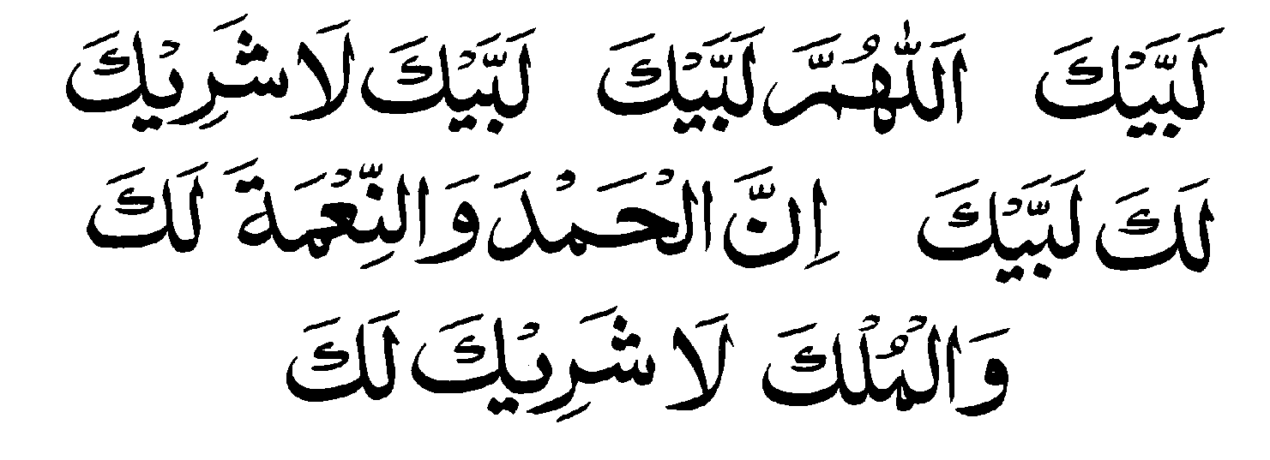
- Talbiyah: - Once the pilgrim has entered into sacred state of Ihram, has offered the prayer and declared his intention of Hajj or Umrah, he has to pronounce Talbiyah the formula prayer.
The pilgrim must repeat this formula prayer countless of time, alone or in-group, until the completion of all the Umrah rites or until the day Nahar (Sacrifice) in Hajj.
- Iztiba: - The keep upper seamless cloth of Ihram wrapped round the torso (upper part of the body) in a way as to keep the right shoulder open.
- Hajar-e-Aswad: - (The Black Stone). It is an oval shaped stone about 18 centimeter in diameter. This sacred stone was brought by Adam (PBUH) from Paradise and set in the angle of Ka`abah.
- Multazim: - It is part of the wall of Ka`abah between the Black Stone and the entrance to Ka`abah. It is tradition to recite invocation seeking salvation and rubbing the chest with it seeking a salvation.
- Tawaf: - (Circumambulation) Going round the Ka`abah seven times keeping the House to one’s left. Each round is called a “Shawt”.
- Mataf: - The wide space around Ka`abah where Tawaf (circumambulation) is performed.
- Ramal: - In the first three circles or rounds in Tawaf a male pilgrim has to walk a little faster than normal with stretched shoulders.
- Istilam: - (Pointation) If it is not possible to kiss the black stone or even to touch it then one can point towards it with open palm or by an stick.
- Saee: - Saee is the rite of walking seven times in procession between the hillocks of As-Safa and Al-Mafwah in accordance with the prescribed law. Each one way journey between the two hillocks is counted as a length (Shawt) out of seven to be performed.
- Zam-Zam: - This well is located inside the Haran. Drinking of water of this well is a tradition after performing Tawaf also splashing on body and clothing with Zam-Zam water is rewarded. Generally any invocation after drinking the Zam-Zam water is reward by Allah. This water cures several diseases too.
- The history of Zam-Zam spring go back to 2500 BC when it started gushing at the feet of infant Ismail, the son of Ibrahim (PBUH) and Hajira. It was a miracle of God since Mak`kah was a barren valley overlooked by two hills As-Safa and Al-Marwah. People go there to quench their trust.
- Hateem: - It is the portion of land, in the shape of an arc, on the North of Ka`abah which was left out from inclusion when Ka`abah was rebuilt. It is obligatory to include it during Tawaf.
- Meezab-e-Rahmat: - It is an open pipe to drain out rainwater from the roof of Ka`abah. It is so situated such that the water falls in Hateem. It is recommended to pray in Hateem and seek blessing of God standing below the Meezab-e-Rahmat.

The Holy places in and around Mak`kah
- Ka`abah or Baitullah: - It is the most sacred center of Islam, the House of God, around which the pilgrims perform Tawaf, Muslims, the world over keep their face towards it while offering prayer. The Holy Mosque where Ka`abah is situated is called Masjid-al-Haram. It is a cubical structure 15 meters high and 12 by 13 meters square. It is covered by an immense piece of black drapery (kiswah) which has verses from Holy Quran embroidered all around it in gold thread.
- Rukun-e-Yamani: - The southwest corner of Ka`abah is known as Rukan-e-Yamani since it faces Yeman.
- Rukun-e-Iraqi: - It is the Northeast corner of Ka`abah facing Iraq.
- Rukun-e-Shami: - It is the Northwest corner of Ka`abah facing Syria.
- Muqam-e-Ibrahim: - It is also an stone from Paradise used by Prophet Ibrahim (PBUH) to stand on it while raising the walls of Ka`abha. It is now protected in glass case situated in Mataf at a short distance from Multazim. One is bound to offer two rakat optional prayer (Nafil) after completing Tawaf and Saee.
- Ghar-e-Hira: - This grotto (Ghar) is located about 20 meters from Ka`abah on the top of hill called Jabl-e-Noor that can be seen while going to Mina. It was at this secluded place that the prophet (PBUH) was in the habit of seeking refuge for three years preceding his mission. It was in this grotto (Ghar) that the Prophet received archangel Jibreel and the revelation of first five verses of Holy Quran.
- Hudaibiya: - It is a place while on way from Jeddah to Makkah a little before the boundaries of Haram. There is Mosque over here. The Holy Prophet has entered into an agreement with infidels of Mak`kah. Bait-e-Rizwan (the oath of allegiance) was also executed here.
- Janat-ul-Muallh: - This grave-yard is in Mak`kah where Ummul Momineen Hazrat Khadija (RAH) is lying buried besides many other companions of Holy Prophet (PBUH).
- Masjid-e-Jin: - This is the mosque where Jins (a sort of creatures, which are normally invisible to human eyes) listned the Holy Quran.
- Masjid-e-Taneem: - This mosque is about three miles form Mak`kah. It is also known as Masjid-e-Aisha. Usually pilgrims staying in Mak`kah don their Ihram here as Meeqat for Umrah.
- Masjid Mashar-al-Haram: - It is a big mosque in Muzdalfa.
- Masjid-e-Shajra: - This mosque is situated in front of Masjid-e-Jin.
- Jabal Abi-Qabees: - When a man named Abi Qabees built his house on this hillock, people named it Jabl-e-Abi Qabees. It is reported that this was the first hill that appeared on the planet earth.
- Muvallid Sharif: - This is the house where Holy Prophet (PBUH) was born. Here now is housed a library.
- The House of Hazrat Khadija: - This is the house where Holy Prophet (PBUH) stayed till his migration to Madina. Most part of the Holy Quran was reveled on the Prophet here. It is a sacred house next to Masjid-e-Haram in Mak`kah.

تلبيه

I am present
O God, I am present. You have no partner
I am present, Indeed praise and bounty are
Yours and the realm
You have no partner.

TALBIYAH
(The formula prayer)
Excellence of Talbiyah: -
It is reported by Hazrat Sohail Bin Sa`ad that when a pilgrim intending to perform Hajj or Umrah say Talbiyah all live or dead on his right and left repeat Talbiyah with him.

Issues Related with Talbiyah: -
- After entering into Ihram and declaring the intent of Umrah or Hajj it is a condition to say Talbiyah in full and loudly. If said quietly or in heart only, one will not be considered to have entered into Ihram.
- As an order Talbiyah is obligatory, sunnah or even optional. Therefore saying Talbiyah at least once after entering into the sacred state of Ihram is must and after that repeating countless of time, alone or in group, until the day of Nahr (sacrifice). It is in uttering the Talbiyah that completes the entry into sacred state of Ihram.
- If some one greet a pilgrim who is saying Talbiyah there is no harm to answer him as return of greeting but it is preferable to complete the Talbiyah and then answer the greeting.
- It is good to say Talbiyah between obligatory and optional prayers.
- If one is among a gathering, each one should say his own Talbiyah and not collectively.
- It is prohibited to cut short the Talbiyah or leave it in the middle.
- If one sees something new or amazing he should say Talbiyah on this occasion.
- Men should say this formula prayer (Talbiyah) a bit loudly but not in a shouting manner.
- It is preferable not to offer greeting (Salaam) to one who is busy in saying the formula prayer rather wait till he finishes it.
- If one is dumb, he should keep his tongue moving as if he is saying Talbiyah.

Reward of saying prayer in Masjid-e-Haram
The reward of one prayer in Masjid-e-Haram is equal to one Lac prayers elsewhere. Allah the Merciful rewards fifty thousands times for each prayer in the Prophet’s mosque in Madina.

Offering Salat in Masjie-e-Haram
While offering prayer at any place in Masjid-e-Haram, one should always face the Ka’abah. If failed to face the Ka’abah in prayer it will be void. One has to be very careful about the frontage of house while offering prayer in close vicinity. Since standing at distance it is enough to maintain the direction of Ka`abha. If Hateem is falling in between even then one should face Ka’abah.
There are broad colored concentric lines on the entire mosque floor. One should put his heals on the line for a correct direction towards the Ka`abha.

Prohibited Times for Prayer
There are certain timings when it is prohibited to say prayer: - These are:
- When the sun is rising
- When sun is crossing the meridian (Zawal)
- When the sun is setting.
Prayer offered on these timings shall be void and will have to be repeated.
After the start of time for early morning (Fajar) prayer it is prohibited to say any other prayer except sunnats, funeral prayer or the missed prayer. And having offered the Fajar prayer it is prohibited to say any prayer till the sun has risen fully.

Congregational prayer on radio sound
It has been noticed that some pilgrim who could not go Misjid-e-Nimra in Arafat join the congregation listening it through radio. They make the radio set as the prayer leader (Imam) and follow through its voice. This is wrong and such prayer has no validity.
For a congregational prayer it is necessary to have a prayer leader (Imam) and people standing behind him in rows. The distance between the Imam (prayer leader) and those behind should not be more than that of two rows and there should not be any physical object such as tent or room in between the prayer leaders and those standing behind. A group of persons can select a most respectable person from among themselves as prayer leader. If no one is willing to lead the prayer them each one can say his prayer. But in no way one should follow the voice from radio or loudspeaker.

Some Rules and Etiquettes about Prayer
- Some people, while in journey offer combined prayer of noon, afternoon, evening and night. This is not allowed in Hanafi school of thought. Combined prayer, only as an exception, is allowed in Arafat and Muzdalfa and beyond these two occasions no where and at no time of year combined prayer is permitted. Even if one is traveling to Madina, two prayers can not be combined.
- It has been observed that in Haram some people lie down and go into asleep. On wake up they immediately stand up to say the prayer. Such prayer is not valid, as the pilgrim is required to go through fresh ablution after wakeup from sleep.
- One should not offer any prayer on the hillocks of As-Safa and Al-Marwa.
- Hateem is also a part of house of God. If one can not get an opportunity to go inside the Ka`abah, he should offer the optional prayer in Hateem, preferably below the Meezab-e-Rahmat.
- It has been observed that sometimes people line up ahead of prayer leader (Imam) outside the prophet mosque or Masjid-e-Khaif in Mina. This is incorrect. Prayer of those standing ahead of Imam is not valid.

Pass by from the front of one busy in Prayer
While going round the House of God in Tawaf if one passes by from the front of some one busy in prayer there is no harm or sin. But in normal course one should not pass from a distance less then two paces of prostration (Sijda).
As usual, one should not pass from the front of one offering prayer unless there is some compulsion.

Abbreviated Version of Prayer (Qasar)
The abbreviated (Qasar) version of Noon and Afternoon prayer is offered in Arafat while in Muzdalfa, the evening (Maghrib) and night (Isha) prayers are offered jointly one after the other.
According to Divine Law if a believer go out of his place of permanent residence and go to a distance of three day’s walk, he can abbreviate his prayer. That will be two Rakats of obligatory (Faraz) prayer. There will be no change, however, in three and two rakats of late evening and early morning prayers and three rakats of Vitar in night prayer.
This condition of abbreviating the prayer (Qasar) remain valid only if his stay at new place in less then 15 days. It one moves out from the first place of temporary stay in less than 15 days and goes to second place, he will be considered a traveler (Musafir) at both places. In today’s measures the three days walking distance is approximately 77 kilometers or 48 miles.
If one stays in Mak`kah for 14 days and five days in Mina and Arafat, he will be a non-resident, a traveler (Musafir) in Mak’kah.
If a pilgrim arrives in Mak`kah so that up to 8th ZilHajja it is less than 15 days, he will be non-resident because within this period of 15 days he may go to Madina and afterward to Arafat. He will have to offer abbreviated prayer in Arafat and Muzdalfa.
A resident of Jeddah or Mak`kah if travels between either station shall not be a traveler (Musafir) since the distance between the two places in less than 48 miles or 77 kilometers. But one living in Jeddah when go to Mina and Arafat he becomes a traveler.
For a traveler (Musafir) it is prohibited to offer full prayer of Mid-Day, Afternoon and Night. It is rather a sin. However by chance or forgetting one offered full prayer, the prayer shall be considered as optional (Nafil) and he will have to repeat the prayer. Abbreviation is not applicable for Sunnah prayers. These shall be offered as prescribed. In a state of journey one can leave Sunnah if one is in a hurry otherwise there is no excuse to leave them specially of early morning (Fajar) prayer.
A pilgrim shall be considered to be a resident of Mak`kah if he is likely to complete 15 days in Mak`kah before 7th of Zilhijj. Such persons shall offer full prayers in Mak`kah, Mina, Arafat and Muzdalfa.
Resident prayer leaders in Mak`kah and Madina lead full prayers in their mosques. A pilgrim, who fall in the category of traveler (Musafar) as he do, when offering prayer in the lead of local prayer leader, shall offer normal and full prayer. Some ignorant people cut short their prayer in between. This is wrong and their prayer becomes invalid.
If the prayer leader, in Arafat, is a resident he will lead the full prayer without abbreviations. All those present in this congregation shall have to offer full prayer even if they are travelers (Musafir). If the prayer is being offered in the individual tents and in separate groups then it is necessary to confirm that the Imam is resident or non-resident.
If prayer leader in Arafat is non-resident, he will have to lead abbreviated prayer of mid-day (Zuhar) and Afternoon (Asr) ie two rakats only for each time. Those who are in the congregation and are traveler (Musafir) they will follow the leader for abbreviated prayer. But those who fall in resident category even in Arafat shall complete full prayer without breaking the continuity after the Imam had closed his prayer. If they make any mistake in their last two Rakats they need not to say rectification Sijda since they are still behind the Imam.
If a prayer leader in Mina or Arafat is a resident he shall not abbreviate the prayer. It he does so, his prayer and of those who are following him shall be void. On such occasion the pilgrim, should arrange their congregation at their place of stay i.e. tents and that may be abbreviated or full as the situation demands.

Ihram of a Minor
If a child is a minor, but can understand the idea and instructions, he shall don the Ihram himself and perform all the rites of Hajj or Umrah like as a grown up and matured. However if the child is too young the guardian shall put over him the Ihram.
If the child is too young and can not understand properly yet he dons Ihram himself and tries to perform the Hajj rites, his actions shall not be valid.
A grown up child should carry the small child in his lap for the performance of Hajj rites.
The guardian is bound to protect and keep him away from all those things and acts which are prohibited while in state of Ihram. However if some act is committed by mistake it will not involve compensation (Jaza) either from the child or from the guardian.
If the child is male he will don the similar Ihram as grown up people do. If a child leaves some rites or misses, no compensation shall be deemed due.
If the child is too young and the parents or guardian is carrying him the guardian shall declare his intent of Tawaf along with that of the child. Thus the complete Tawaf (circling around Ka`abah) shall be good for both.

All About Ihram
Ihram is the ritual entering into the sacred state, by a pilgrim, with a view to enter the sacred land for Hajj or Umrah or for both. Ihrams comprise two lengths of white cloths, each about two-meter long, without seam. The first one serves as loin clothes (Lungi) and is wound around waist. The second piece covers the whole torso. This makes the pilgrims a unified man of human beings.
Once a pilgrim has donned Ihram and declared his intent (Niyat) and has pronounced Talbiyah, (the formula prayer), some of things and acts become unlawful (Haram) for him.

Issues Related with Ihram
- The intending pilgrim shall, at first take bath or at the minimum the ablution at his residence. He will then put on Ihram and offer two genuflection (Rakat) of optional prayer. It is preferred to recite, in first Rakat, Sura-e-al-kafiroon after the ritual Fatiha (opening) while in second Rakat he should recite Sura-e-al-Ikhlas after the Fatiha. Thereafter, he should declare his intent (Niyat) of Umrah or Hajj, as the case may be, and pronounce Talbiyah (the formula prayer) followed by Darood-e-Sharif. One should not skip bath or ablution and the optional prayer associated with donning of Ihram without genuine reason on this occasion. If it is forbidden (Makrooh) time for prayer one leave it, and declare intent and say Talbiyah.
- If one could not take bath, the ablution is sufficient for donning Ihram.
- If one declared the intent and said Talbiyah after the obligatory (Faraz) prayer the rites has been completed.
- If there occurs a seminal discharge, while in Ihram, that does not affect the Ihram. It is sufficient to take bath and wash the cloth. One can even change the cloth.
- If one is injured, while in Ihram, it does not affect Ihram. Neither any compensation falls due.
- It is forbidden to take medicinal injection while in Ihram.
- One can take bath while in Ihram but he should not rub the body to remove dirt nor use the scented soap, which is prohibited in Ihram.
- One can comb his hairs or beard in such a manner that hairs does not break. Similarly scratching of body should be done carefully and lightly so that body hair does not break. Intentional tearing or detaching of hair during the sacred state of Ihram is prohibited.
- Looking into mirror and brushing of teethes with Miswak is allowed in Ihram.
- The slaying of all land animals is prohibited. Even the most harmful creatures and insects are not permitted to be killed. They should only be thrown apart.
- It is preferred that the two pieces of Ihram cloth should be white. But if coloured cloth is used, it is permitted and desirable.
- In winter warm blanket or quilt can be used but the head and face should remain open.
- The fastening of belt to hold fast the loincloth and to keep money in its pocket is allowed.
- Ihram cloths can be replaced if they get dirty, polluted or unclean. Any of the two pieces are allowed to be washed by taking off from the body for short time.
- While in Ihram, one can wear wristwatch use, reading glasses or earphones.
- A pilgrim while in Ihram is not allowed to cover his head or put a band on the forehead. If he covered his one fourth head continuously for a day or night immolation (Dum) shall fall due. If the covering was less than one fourth of head and for less than a day or night an offering shall still fall due.
- The shoe permitted in Ihram should be the unstitched sandals that leaves the heal and toe uncovered.
- Hunting of a land-based animal is prohibited while in Ihram. A compensation falls due in such case. However, one can slaughter goat, cow or chicken within the boundaries of Haram.
- Some pilgrims have been noted to put on a second time Ihram after the first Tawaf and Saee without shaving the head or even partially cutting the hears. This is not permitted. One should complete all the rites associated with the first Ihram and then go for the second Ihram. If done otherwise i.e. putting one Ihram over the other an immolation (Dum) becomes due compulsorily.

Janayat: Doing things against Restrictions
As soon as a man or woman enters into the sacred state of Ihram, certain restrictions becomes binding on him/her. Acting against or breaking these restrictions in known as “Janayat”.
Any forbidden action committed either deliberately, accidentally, out of ignorance or out of necessity (like illness) requires atonement. In certain case this atonement consists of immolation (Dum) animal sacrifice while in other cases it requires offering.
An animal sacrifice or immolation (Dum) comprises slaughter of a goat/sheep not less than one year in age or one seventh of a cow or camel. In simple these animals should fulfil all the requirements of animal sacrifice observed in Eid-ul-Azha. An offering consists of two kilogram of wheat or cost of this quantity of wheat that can be given to any deserving poor.
However when animal sacrifice (Dum) falls due, it means slaughter of an animal, that too, within the limits of Haram. Oneself is not allowed to consume the meat of the animal slaughtered as atonement (Dum).

Other Restrictions while In Ihram
- Use of perfume
- To cut the finger nails
- To cut the hairs
- Men are prohibited to wear stitched cloth. Women can use their usual cloth but they have to keep their head covered. The head scarf cover should not touch cover or rub with forehead.
- Men are not allowed to wear socks or shoes that does not leave the heal and toe uncovered.
- Sexual relations, flirting, kissing or getting engaged are strictly prohibited. The sexual act, while in Ihram, invalidate the pilgrimage and the punishment of slaying an animal falls due on both man and woman.

When animal sacrifice (Dum) falls due
- Going round the house (Ka`aba) in Tawaf-e-ziarat without ablution. However if one repeats the entire Tawaf after the fresh ablution, slaying of animal (Dum) is not required.
- One has to slaughter animal, as compensation if one omits Saee in full or partially or seeking help of wheel chair without actual need.
- If one moves out from Arafat before sunset, sacrifice (Dum) becomes due. But if one realizing the mistake, returns back to Arafat, atonement becomes annulled.
- Omitting Waqoof (standing) at Muzdalfa without reason.
- Omitting the stoning of Jamarat due on a day, atonement falls due.

Use of Perfume
- While in Ihram the use of perfume is equally prohibited for men and women.
- If by mistake, intentionally or un-intentionally one used the perfume, compensation falls due.
- Not only the use of perfume but also using scented hair oil or washing the body by scented soap is also disallowed.
- However if some one used perfume or any scent before donning the Ihram and its fragrance continued for sometime, there is no harm.
- If perfume is spread on hands, feet or any other part of the body, while in Ihram, slaughter of animal (Dum) becomes due. However, if washed immediately on realizing the mistake or has been applied on some smaller part of the body like nose, ear, eye or just on finger, offering (Sadaqa) falls due.
- If perfume is applied in small patches on the body and that combined, together, becomes a large body part then atonement (animal sacrifice) falls due.
- If one used a stitched and scented cloth during the sacred state of Ihram, that will be treated as two sins and the compensations shall be two according to the forbidden actions.
- One should immediately remove the scented cloth and wash the spot of the body where scent has been applied even if he has paid the offering. No let off is permitted. Still, if the scented cloth not removed or perfumed part of the body not cleaned even after paying the offering, one shall have to pay a second offering.
- If by chance, the body or cloth gets scented, one should not use his own hands to wash it. Either rinse it with water or ask someone, not in Ihram, to wash it.
- Use of un-scented antimony powder (Surma) in eyes is permitted while in Ihram. If one used scented surma upto two times, one will have to pay the compensation. If used scented surma more than twice, slaughtering of animal (Dam) becomes due.
- If one took flavoured or scented food item while in Ihram and some of it remained stuck up in mouth, atonement (Dam) falls due on this irregularity. Yet he swallowed all, and nothing left in mouth, only offering falls due. Lightly flavored cooked food can be taken.
- Spices are permitted to be used in cooking the food.
- Those who chew pan are not allowed to use clover or cardamom or highly scented tobacco while in Ihram.
- Fruits with aromatic smell can be taken but smelling of flower or fruit is prohibited.
- Tea or coffee with heavy fragrance or flavour is not allowed. If taken tea that was with light flavor, offering shall fall due.
- Aereated water, like cold drinks, without any flavor is allowed. If flavoured drink is taken one will have to pay offering.
- One should avoid the use of tincture with strong smell on an injury.
- Food and eatable cooked in oil or butter (Ghee) are allowed but the oil or butter should be without fragrance.
- Pilgrims often smear scent (Itar) on Black-Stone in Ka`aba or Rukun-e-Yamani. Since scent or any other fragrance is prohibited, one should avoid putting his hand or kissing it while in Ihram.

Use of stitched cloths
- Wearing of stitched cloth, while in Ihram, is prohibited for men. If some one used stitched cloth for a whole day or night or for time equal to a day, atonement falls due. If used for a short time offering falls due. If used for a while, less than an hour or so, offering of an handful wheat shall suffice.
- If one used stitched cloths for more than one day, he will have to slaughter an animal as compensation.
- If one entered the sacred state of Ihram, with stitched cloth still on body, expressed his intention of Umrah and recited Talbiya but did not removed the stitched cloth for a day or night, he will be sinner and the punishment in such case is slaughter of an animal (Dum).
- If an stitched cloth like shirt or shalwar is simply wrapped around the body but not put on like a normal wear on that body part for which it is made, there is no harm although it is not good to wrap any other cloth besides the two unstitched pieces of cloth.

Covering of the Head and Face
- While in Ihram, it is prohibited for men to cover head or face. If by mistake or by chance full head or face or even half the head or face got covered, offering (Sadaqa) falls due.
- If for an whole day or night, one kept his head or face, fully or partially covered or a woman kept her face full or partially covered with cloth for an whole day or night immolation (Dum) becomes due. Yet if less than one quarter remained covered or the time of covering remained less than a day or night, offering shall have to be paid.
- If one covered his head with something unusual or uncommon like wood, glass, a sheet of iron, silver, stone etc no harm is done.
- Umbrella is allowed to be used for protection from sun or rain.
- A pilgrim, while in the state of Ihram, should not stand as much close to Ka`aba that its black drapery (Kishwah) touches the face or head. It is disapproved (Makrooh).

Shaving and cutting the hairs
- While in Ihram, it is prohibited to cut hairs or shaving, plucking or merely trimming the hairs by any means.
- If one shaved or trimmed hairs by mistake or deliberately offering, (Sadaqa) shall become due.
- If one shaved one fourth of head or trimmed beard upto about one fourth while in Ihram, he will be sinner and immolation of an animal fall due. If lesser than one fourth, offering will suffice.
- If a woman cuts her hairs equal to one finger length before Saee of Umrah, she will have to sacrifice an animal as compensation. However if the hair cut is less than one fourth of the prescribed length, only offering shall be enough.
- Shaving hairs of the armpit and of naval area is prohibited. If one acts against this prohibition, he is liable to slaughter an animal.
- If one shaved head while in Ihram, he is bound to slaughter an animal as compensation. If he forgot and shaved beard he will be liable for another Dum.
- If some hairs got burned while cooking, one is liable to offering (Sadaqa)
- If during ablution or for some other reason, three hairs from beard or head got detached, one should offer one handful of wheat.

Cutting of Nails
Cutting of nails while in the sacred state of Ihram is also prohibited like cutting or shaving the hairs.
- If in one sitting, one cuts one or two nails of each hand and feet, one has to immolate an animal. Again if one cuts off the nails from hand and feet on four different times, he is bound to slaughter four animals.
- If by chance or accidentally a nail is damaged or breaks; its detachment does not entail any compensation.

Sexual Relations
Sexual relations, flirtation, kissing between male and female or becoming engaged are strictly prohibited in the sacred state of Ihram. Such acts during Ihram automatically invalidate the pilgrimage.
- If one kissed his wife while in Ihram or embraced her it will not invalidate the Umrah but he will have to immolate one animal.
- If one faced or saw a woman with lust or just thought of it and felt some seminal discharge, there will be no compensation due but he will have to take bath.
- If one performing Umrah engage himself in any sexual act before completing all the rites, his Umrah does not become invalid yet immolation of an animal falls due on him.

Badna: Slaughtering of one full cow or camel
Immolation or slaughter one full camel or cow is called Badna, it falls due on a sinner when;
- He committed sexual act before shaving of head, (which is the last item of the series of rites), after the Waqoof at Arafat, stoning of three pillars or animal sacrifice.
- A woman who performed Tawa-e-Ifada during menstrual period.

An unlawful act due to some reason
- If due to some valid reason one used stitched cloths, used perfume, trimmed the nails or shaved the head or covered the head due to pain, atonement falls due. Wherever immolation, (slaughter of an animal) falls due, it has to be carried out within the limits of Haram. Yet in case of an offering the pilgrim has the choice to distribute three kilograms of wheat among six poor or keep fast for three consecutive days.
- If due to some reason one acted unlawfully during Ihram and offering (Sadaqa) has fallen due, he has the choice between offering or a day’s fasting.
- Immolation of animal, because of committing any prohibited act during Ihram, is to be carried out within the limits of Haram whereas an offering can be made outside these limits.
- A pilgrim immolating an animal is not permitted to use or eat from it. Neither one who pays Zakat or on whom sacrifice is obligatory can not take any thing out of the sacrifice.
- Some well to do person deliberately commit an unlawful act while in Ihram, then sacrifice an animal. This is incorrect. Such people are sinner. It is likely that his prayer or Umrah does not get ascent by Allah. Such people should seek forgiveness.

About women
(Mahram is must for woman’s travel)
According to divine laws, a woman can not travel, by any mode of transport i.e. by car, train or aeroplane for any worldly business or religious duty without a Mahram.
Reported by Hazrat Abdullah bin Abbas that the messenger of Allah said; A man (Na-Mahram) for a woman, should not stay with a woman when there is no other or in seclusion. Neither a woman should travel without a Mahram. Hearing this, a man said; O, Apostle of God, I have been enrolled for Jihad while my wife has proceeded for Hajj. The Holy Prophet (PBUH) said; You go to Hajj with your wife. (Bukhari & Muslim)
This prohibition is for women of all ages. Some women think that they can undertake the journey in company of several other women without a Mahram. This thinking is wrong. The Holy Prophet (PBUH) has said with emphasis about this prohibition. Even a journey for Umrah or Hajj without the Husband or Mahram is not permitted and is a sin. Those women who proceed on journey for Umrah or Hajj without the company of Mahram against the Divine law become sinners. Their Umrah or Hajj bears no significance.

Who is Mahram
All those men with whom a Muslim woman can not marry are Mahram for her. They are father, brother, maternal / paternal grandsons, son-in-law, real maternal / paternal uncles.
Maternal / paternal cousins are Non-Mahrams and a woman can marry with them. A woman’s brother-in-law is also considered to be non-Mahram since after the death or divorce to her sister she can marry him.
A woman should avoid traveling with a Mahram whose character is of dubious nature. An adopted father, brother or son also falls in category of Non-Mahram. They are just like any other stranger.

Ihram of Ladies
The conditions of Ihram for ladies are almost the same as for men. Ladies can, however, wear their normal dress whereas men has to don two pieces of white cloth as Ihram. Ladies, too, are to take bath, perform ablution, offer two rakat optional prayer, declare intent (Niyah) and recite Talbiyah (the formula prayer). The other restrictions too are almost identical.
- If a woman passing through her menstrual course, she can performs ablution only but should not offer the optional prayer. She should sit on prayer mat facing the direction of Ka`aba, remove any cover from her face, declare the intent (Niyah) of Umrah and recite Talbiyah three times in low voice and Drood-e-Sharif.
- If a woman has to cross the Meeqat while she is still in the menstrual cycle, she can put on Ihram, declare the intent of Umrah and recite the Talbiyah. However, while in Mak`kah she will have to wait for coming out of the menstrual cycle before performing Tawaf and Saee.
- Ladies can use all their usual wear including shoes but will not put any cover on their face.

Veil for Ladies
According to Divine Laws, veil or cover for woman in Islam is obligatory in all circumstances. It is sin for a Muslim woman to discard veil and mix up with men. Muslim woman should desist form this sin.
There is a misconception in certain quarters that while on Umrah or Hajj pilgrimage, all Non-Mahrams become like real brother and sister. This is wrong.
Veil or cover is a divine order and has to be observed as an obligation. Ladies are cautioned to be more careful about veil or covering themselves while in Mak`kah or Madina in view of the sanctity of these two houses.

Observance of Purdah while in Ihram
Purdah or covering is obligatory for women while in Ihram during the performance of Umrah or Hajj, despite that she can not cover the face. Yet to observe the condition of veil they can put on special type of hat with extended shade. A very thin cloth is attached with this shade that will function like veil but it should not touch the face skin. Due care has to be taken while using this veil attached hat.

Miscellaneous Issues & Propositions
- Some women consider that putting on a white scarf on head as a necessity and part of the Ihram. This is not correct since a woman has to use a scarf to protect her hairs from falling or to keep the hairs covered from Na-Mahrams, but the scarf should not be considered as part of Ihram.
- Some women while performing ablution do not remove their head scarf and simply rub the scarf covered head with wet hands. This is incorrect and the ablution remains incomplete. They can not offer prayer with an incomplete ablution. They should remove the scarf for ablution and rub the hairs with wet hands (Masah)
- While in the state of Ihram, use of scent, perfume, covering the face, cutting the hairs or nails, sexual contacts are prohibited.
- Ladies should not mix up with men, as much as they can in Tawaf or Saee. However if there is some compelling reason, like Tawaf-e-Ziarat with shortage of time, a women can perform Tawaf at the outer periphery of Mutaf, which is usually less crowded, with due care as to avoid the rubbing with men. They can perform Tawaf on upper floors, which are usually not so crowded.
- Women should not try to kiss the Black Stone in a crowded condition. They can make a gesture of simulated touching.
- If there is crowd at the place of Abraham, women can say their prayer at any other place in Haram but facing place of Abraham.
- If some women start menstruating just after Umrah Tawaf, she can perform Saee and cut her hairs as prescribed, thus completing the Umrah rites. However she can not offer the optional thanksgiving prayer due after Tawaf and Saee in such state. Place of Saee is not part of Haram.
- In the Saee procession, women need not to accelerate their pace in the space marked by green posts. It is obligatory only for men.
- It is unlawful and forbidden for ladies to shave off their head altogether.
- For a symbolic cutting of hairs after Saee, women should take help of another woman or otherwise of a man who is Mahram to her. She should stretch her hairs in three parts and trim them equal to about two inches to two and half inches that will cover all lengths of hairs.
- Ladies are equally rewarded by Almighty God if they say their prayers at their place of stay during Hajj and Umrah as if they have prayed in Ka`abah or Masjid-e-Nabvi.
- Ladies are not bound to offer their prayers in congregation in Ka`abah or in the Prophet’s mosque in Madina. However they can visit the two houses for fulfilling the rituals associated with Umrah, Tawaf, Saee or Ziarat.
- Ladies can come to Prophet’s mosque (Masjid-e-Nabvi) to offer their salaam and compliments to the Holy Prophet (PBHH) and if it is time for a regular prayer they can stay and join the prayer. Yet it is preferable for ladies to say their prayer at their place of stay.
- A woman can stay in Waqoof at Arafat and Muzdalfa even if she is in menstruating cycle. For these rites it is not conditional for women to be clean.
- Women in the cycle of menstruation can not perform Tawaf-e-Ifada (Ziarat). They should wait to come out of this menstruation period even if the 12th of ZilHijja passes away. There is no haram. They can go round the House for Tawaf followed by Saee after becoming clean and later can perform Tawaf-e-Ifada (Ziarat). No atonement falls due in this particular circumstances.
- If a woman by virtue of her habit and experience is expecting the start of mensuration, yet there is some time in which she can perform whole of Tawaf-e-Ziarat or a minimum of four circles around the House, she must do so If, however, she waited and started menstruating and three days of Hajj passed away, she will have to immolate an animal. If the time fell too short of her expectation that four rounds of circling the House could not be performed there will be no compensation due.
- A woman who has completed all the rites of Hajj except the farewell Tawaf (Tawaf-e-Wida) but she can not wait due to departure times having arrived, and starts menstruating she is excused of this Farewell Tawaf. She needs not to enter the mosque in an unclean state. She can invocate form outside the mosque.
- If a woman left Mak`kah in an state of menstruation foregoing the Farewell Tawaf but before crossing out of the boundary limits of Mak`kah menstruation stopped, she is bound to return back and perform Farewell Tawaf (Wida). Yet if she has crossed over the limits of Mak`kah, after which she came out of the unclean state, she need not to return back. If she returned to Mak`kah without crossing the limits of Meeqat, she will be under the obligation to perform Tawaf-e-Wida (Farewell).
- There is no need of a particular declaration of intent for Tawaf-e-Wida. If a woman has performed one or two optional Tawaf before going into the menstruation cycle, she need not to wait any more. Her optional Tawaf shall be deemed as Farewell Tawaf (Wida)
- While in Madina, if a woman could not complete all the forty prayers due to start of menstruation cycle, God in His Mercy shall excuse her since the ordeal was beyond her control. She can invocate as much as she can on every hour of prayer after performing the ablution. This invocation is enough for her.
- Ladies who except the menstruation just during the days of Hajj or Umrah, they should consult their Doctor and take some medicine that can stop the menstruation temporarily. Yet they should use the medicines only for the days of Hajj or Umrah and not for longer period and repeatedly which may create harmful effect.

Women Not Allowed To Mix with Men
It has been noted that some women, in Haram (the sacred mosque) forcibly make their place for prayer among men. This is not permitted in Divine Laws (Shariat). It is reminded that prayer of three men, on left, right and front, is spoiled if a woman is standing close to them during congregation without any physical obstruction, disregarding even the family relationship between them. It is therefore necessary that women should form their group and rows separate from men. However, if a man and a woman are offering their prayer, in individual capacity (not behind a common prayer leader) their closeness shall not have any adverse effect.

Circumambulating (Tawaf)
Literally Circling around anything is called Tawaf. Similarly circling around Ka`bah, the House of God, seven times in Hajj or Umrah is known as Circumambulation or Tawaf.

The Excellence of Tawaf
The Holy Prophet (PBUH) said “that God the Merciful bless the House one hundred twenty times each day. Those going round in Tawaf are rewarded with sixty blessings, forty blessing for those offering prayer in Baithullah (sacred mosque) and twenty blessing are for those who are watching the House.”
- It is reported that one who is going round Ka`abah, as soon as he moves his feet, God forgive one sin of his and record one piety for him.
- The Prophet (PBUH) said “that go round the Ka`aba as much as you can. One the day of resurrection you will find this act as one of the best and feel proud of it.
- It is reported that one who perform seven Tawaf barefooted and bareheaded, he will be rewarded by God as if he has freed a slave. If one perform seven Tawafs of House of God in rain, all his previous sins are forgiven by God the Beneficient.
- If one performs fifty Tawaf of Ka`aba, he is devoid of sins like a newly born child is free from sins.

Kinds of Tawaf
There are seven different kinds of Tawaf.
- Tawaf-e-Umrah: - This Tawaf is essential and an obligatory part of Umrah.
- Tawaf-e-Qudoom: - (Circumambulating upon arrival). It is the official way of greeting Ka`aba instead of the usual prayer (Salat) of two Rakats which is performed upon entering any mosque. It is ordained by Holy Prophet (PBUH) that Tawaf-e-Qudoom is Sunnah for all those coming from far off (outside the limits of Meeqat) with the intention of performing Hajj-e-Ifrad or Qiran. But is not compulsory for one coming with the intention of Hajj-e-Tamatto or for Umrah.
- Tawaf-e-Ziyyarah: - (also known as Tawaf-e-Ifadah). This Tawaf is one of the fundamentals or essential parts of Hajj. The rites of Hajj are not completed if one leave it or forget. This Tawaf is performed from the morning of 10th ZilHijj to the sunset of 12th ZilHijj. It has to be performed even if delayed but with the immolation (Dum) of an animal. Generally this Tawaf is performed on the day of sacrifice (1) after stoning the Great pillar (2) the immolation (Nahar) and (3) after shaving of head or symbolic cutting of hairs.
- Tawaf al-Wida: - (Farewell Tawaf). It is duty for every pilgrim coming either for Hajj or Umrah to bid farewell to the Ka`abah before leaving Mak`kah for Madina or for home. After performing this Tawaf the pilgrim must walk backwards as a sign of veneration (this gesture is obligatory)
- Tawaf-e-Nazar: - (offering) It falls due when someone woe for any worldly affair.
- Tawaf-al-Tahiyyah: - This Tawaf is desirable when one enters the sacred mosque. But if one performed any other Tawaf, that will become its substitute.
- Nafli Tawaf: - (optional) Tawaf is a prayer that can be performed only in Mak`kah and no where else in the world. Its excellence is unmatched that may even be an optional (Nafli) Tawaf. It is therefore advised that one should perform as much Nafli Tawaf as he can in the available time after Umrah or fulfillment of Hajj rites. Some people prefer to perform many numbers of Umrah. There is no harm in it but it is preferable and desirable to perform much of Tawaf. Performance of an Umrah takes more time and in that much time one can perform several optional Tawaf.

Rules and Etiquette of Tawaf
- The declaration of intent (Niyat) is compulsory for Tawaf. It one circled Ka`abah without intent, it will not be considered as lawful Tawaf.
- In Umrah a pilgrim has to perform Saee also after the Tawaf, therefore, he should keep his right shoulder open in all the seven circuits of Tawaf. This act of keeping the right shoulder open in Tawaf is known as Iztiba. However, for offering two Units prayer after Tawaf one should cover the right shoulder. It is undesirable (Makrooh) to pray with open shoulder.
- Iztiba is a tradition in Tawaf only. It is not required in Saee.
- Those who intent to go round the House of God (Tawaf) for Umrah, they should move a little faster than the normal walk in fast three rounds. He should keep shoulder high and put step little closer. This is known as “Ramal”.
- Talking irrelevant or doing any worldly deal etc in Tawaf is disallowed. However one can ask or tell any religious question or information.
- Reciting verses from Holy Quran as a matter of invocation during Tawaf in loud voice is prohibited. It may be a source of disturbance for other pilgrims around.
- One should not try to hold or suppress the call of nature or urine during Tawaf.
- If one finds it difficult to kiss the Black Stone (Hajar-e-Aswad) due to crowd then he should touch it with both hand and later kiss the fingers and palms. Even if that is not possible due to milling crowed, on can raise his hands up to ears and then extend the hands towards the Black Stone with palms facing the stone then kiss the palms afterward.
- It has been observed that some people smear the Black Stone with perfume / scent. Since perfume is prohibited for one who is in Ihram, he should avoid to kiss or touch the stone rather should extend his hands only with open palms towards stone. This action is known as “Istilam”.
- It is prohibited to kiss any part of Ka`abah except the Black Stone or the door sill of Ka`abah (the Multazim). Touching the Rukun-e-Yamani only by hand is allowed. If one can not touch the Rukun-e-Yamani then he should not point towards it.
- While circling Ka`abah it is prohibited to keep face towards it or keeping the chest or back towards it.
- During Umrah Tawaf one has to move a little faster than normal walk in first three circles, known as Ramal. If the crowd does not permit fast movement, one should wait for thinning of crowd to perform Tawaf with Ramal.
- If one started Tawaf with Ramal but suddenly due to growth of crowd he could not keep circling with Ramal, he can give up Ramal but complete the Tawaf.
- If one forgot to do Ramal in first or second circle but later came to realize then he should observe Ramal in second or third circle then he should forego the Ramal in the remaining circles.
- While performing Tawaf of Umrah, if one falls in doubt about the number of circuits executed it is better to perform an extra circuits.
- Tawaf can be equally performed on the first or second floor of Masjid-e-Haram.
- Nowadays it has become common that ladies do perform Tawaf with their men, sometimes in objectionable state of cloths such as with open parts of the body particularly hands and feet. These parts come in touch with other people or men’s gaze fall on them. This becomes a cause of apprehension among pious people. According to Shafai school such contacts demand fresh ablution. While according to Hanafi school, Tawaf remains valid but with disapproval (Makrooh)
- Some pilgrims in their endeavour to perform more numbers of Tawaf in the available time run fast pushing other worshipers. This is incorrect. They should carry out their Tawaf with patience without hurting or pushing others.
- It has been noticed that some pilgrims while performing Tawaf-e-Ziarat on first or second floor of the sacred mosque inadvertently slip into the area reserved for Saee. Tawaf into the Saee area is not allowed. Tawaf is to be carried out only in Mutaf, the place reserved for it, come whatever the crowd strength.
- For pilgrims coming from distant places (Afaqi) it is preferable to perform optional Tawaf instead of offering optional prayers.
- Tawaf of the House of God has some preference over Umrah, provided one give all that time to be spent in Umrah, in performing Tawaf.

MEEQAT
Meeqats are certain fixed boundaries on all four corners of Arabia designated by the Prophet of Islam (PBUH) where the pilgrims must don Ihram for Hajj or Umrah before entering Mak’kah. These places were set out by the Prophet in person as commanded by God.
- Any one crossing Meeqat without doing Ihram will be sinner. He will have to return to Meeqat. If one crossed Meeqat without donning Ihram, did not returned back to Meeqat to enter into Ihram and instead put on Ihram else where, he will be liable to penalty ie immolation (Dum). Yet on realizing the mistake he returned to Meeqat to put on Ihram, he does not need immolation.
- All those coming from far off are forbidden to enter the boundaries of Haram-e-Mak`kah without Ihram. The Divine law prohibits them to pass through Meeqat without Ihram.
- If one crossed the Meeqat without Ihram, then donned it somewhere in between but on realizing the mistake, returned to Meeqat before beginning the Tawaf and recited the Talbiyah (the formula prayer) he will be excused from immolation (Dum).
- If one coming from outside the Meeqat, known as “Afaqi”, entered Mak`kah without Ihram, he will be duty bound to perform one Umrah or Hajj as compensation. If he enters Mak`kah several times without Ihram, he will have to perform one Umrah or Hajj as compensation for each entry. Since Hajj falls only once in a year besides strict regulation and government checking does not make it easy to defy the religious binding. Other than Hajj season, one will have to perform Umrah for each violation of Divine restrictions.

Ihram for Air Travelers
Pilgrims from Pakistan or any other country while making their journey by aeroplane should don Ihram at their residence or at the most at the airport since the air journey usually is of short duration. Some pilgrims board the aircraft without Ihram, they should be in know that each aeroplane before landing at Jeddah airport crosses the Meeqat. In such situation those who intend to go to Mak`kah from Jeddah should put on their Ihram before boarding the aeroplane, otherwise they will have to sacrifice an animal as immolation (Dum) as compensation for breaking the Divine law of crossing Meeqat without Ihram. Yet those who intend to go to Madina from Jeddah, in first instance, can proceed in their usual dress. They can put on Ihram while coming from Madina to Mak`kah at Bir-e-Ali Meeqat.

UMRAH
The Umrah or Lesser Pilgrimage is visiting of the Holy places of Mak`kah and Madina with a view to accomplish an individual pilgrimage. Umrah is not a obligation (Faraz) but a tradition which is almost compulsory for those who have the means. It is not confined to any set of time. It can be carried out at any time of the year, excluding the five days of Hajj.

The rites of Umrah are: -
The Ihram as for the Hajj before crossing any specific Meeqat. A declaration of intent to perform the pilgrimage.
The Tawaf or Circumambulation around the Ka`aba. It is an obligatory (Faraz) component of Umrah.
The Saee: The walk in procession, brisk at two spaces, between the hillocks of As-Safa and Al-Marwa. It is a duty (Wajib)
Shaving of Head of men symbolic cutting of hairs for ladies as the closing item of Umrah rites. Once this last rite has been accomplished, all restrictions are removed and the pilgrim can come out of the sacred state of Ihram. He can put on his usual dress and resume all normal functions.

Preparation for Umrah
Before donning the Ihram, the pilgrim should have previously cut his nails, and unwanted hairs. He should take bath and ablution. He will then remove his usual clothes to don two white cloths of Ihram without seam. The first will serve as loincloth (Lungi) and be wound round the waist. The second is to cover the whole torso. One can put a small quantity of scent or perfume before putting on the Ihram in a manner that it does not leave any spot on the body.
The pilgrim then offers two units (Rakat) of optional prayer and seek God’s forgiveness of his sins and salvation. Next he should offer another two optional units (Rakat) of prayer as salutation of Ihram, preferably reciting in first unit Surah-al-Kafiroon after the ritual Surah-e-Fatiha. In the second unit of prayer the pilgrim should recite surah-al-Ikhlas after Surah-e-Fateha. The pilgrim should offer these prayers with covered head.
The pilgrim should then declare his intent (Niyah) wether he wish to perform Umrah or Hajj or both at the same time.


The Niyah of Umrah
The Niyah can be pronounced in voice or can be read silently. Once the rites of Ihram and intent has been performed the pilgrim has only to pronounce the Talbiyah (the formula prayer)
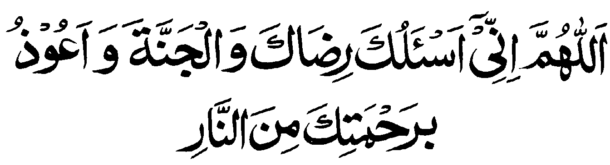
To make the sacred state of Ihram effective a pilgrim has to pronounce Talbiyah at least once after the intent (Niyah) of Umrah. It is good, rather, to pronounce the Talbiyah at least three times followed by Darood-e-Sharif. Then read the following prayer.

Departing From Home
While departing for Hajj or Umrah, seek forgiveness from all dear ones in home and around. Have a collective invocation for the security for all you are leaving behind, for the security of all worldly goods. Depart in good spirit since you are embarking on a journey to seek blessing of Allah, the most merciful, the most forgiving. It is preferable to recite Ait-al-Kursi before stepping out. Give some alms or offering. Keep on reciting Talbiyah and the Third Kalma in voice or silently.

Embarking on Aeroplane
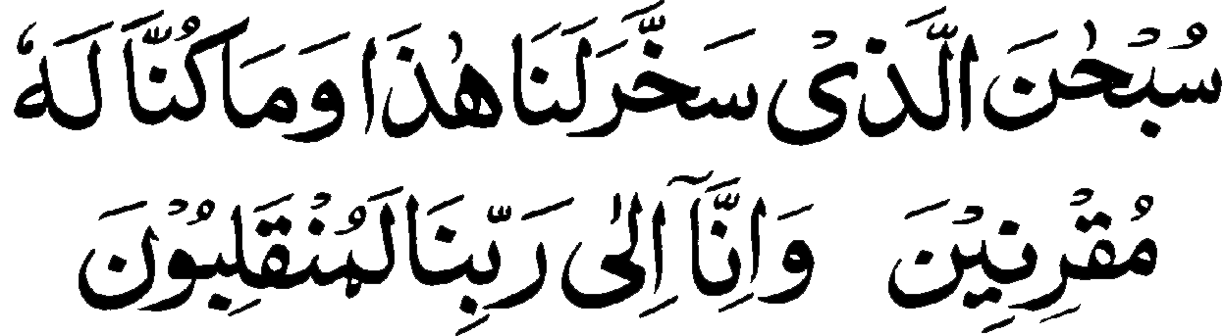
Before embarking on the aeroplane, say the following prayer:
- Although it is good to declare the intent (Niyah) of the journey after donning the Ihram at home, but it is advised that the intent be declared after passing through all legal and emigration formalities at the airport. Once, a pilgrim declares the intent, he is bound by certain restrictions of Ihram that can not be revoked even if some worldly discrepancy is noticed.
- The aircraft’s toilet is usually very small in volume. Therefore a pilgrim should use it very carefully from spoiling the Ihram.
- Do not use the scent, usually found in aeroplane toilets.
- Do not tease anyone in the journey or be harsh or try to hurt anyone. If you are hurt due to some one’s mistake take it calmly with patience and forbearance.

Prayer on Disembarkation

Many thanks to the Almighty God that the air journey, having arrived at Jeddah International airport, has been completed. The disembarkation of pilgrims takes place at special terminal called Madinat-ul-Hujjaj. Here every pilgrim shall pass through all the emigration formalities including custom checking of the luggage.
At some distance from the disembarkation hall, there are separate enclosures for all countries where the luggage, respective to the country, is unloaded by the airport staff. The busses, too, shall be available nearby. Every pilgrim shall take his seat in the assigned bus under the guidance of his group leader. One should ensure himself that his luggage has been loaded in the same bus.
Before the commencement of your drive towards Mak`kah, a representative of the Moallim (Hajj Guide) shall collect all the passports and air tickets. In return he will provide to each pilgrim a leather brace-let as mark of identification as to which Moallim and Maktab, the pilgrim belong. It is imperative for each pilgrim to keep wearing this bracelet all the time till the departure back to home. Some necessary information is printed on these bracelet.

Entering Mak`kah
Having arrived in Mak`kah the group leader shall make arrangements for the stay of the pilgrims. There will be separate rooms for gents and ladies. Take little rest, if you need, otherwise make ablution and start walking towards the Holy Mosque and House of God. One has to perform Umrah at the earliest as first duty of rites of the sacred journey.

Entering the Holy Mosque

The Holy Mosque has many doors (about 98). One can enter the mosque from any door but take note of the door number and some other mark of recognition to avoid any difficulty in tracing the way back. There is very chance of going astray if this care is not taken.
- Prayer on entering the Holy Mosque
- Recite Darood-e-Sharif.
- Express your intention (Niyah) of performing Umrah with recitation of particular invocation (one can say in his own language): “O God, I declare my intention of Etekaf, so long I am in this mosque.”

The First Glance on House of God

As soon as the House (Ka`bha) is in sight, get aside, and recite (God is Great) thrice followed by Darood-e-Sharif. This electric moment is of highest efficacy of all your invocation and prayers. Pray as much as you can in all humiliation. You are standing in front of the most revered House of Allah on this earth. Seek forgiveness weepingly for all your past sins. Pray for your salvation and for Heaven.

Iztiba
Before commencing the Tawaf a pilgrim is to open his right shoulder by pulling this side of cloth under the right armpit. This condition applies for men only.

Umrah (step by step)
- There is a dark brown (now white) drawn out strip on the floor from Black Stone upto verandah where a green light glows all the time. Stay out near the strip so that the strip is on your right. The Black Stone, too, shall be own your right.
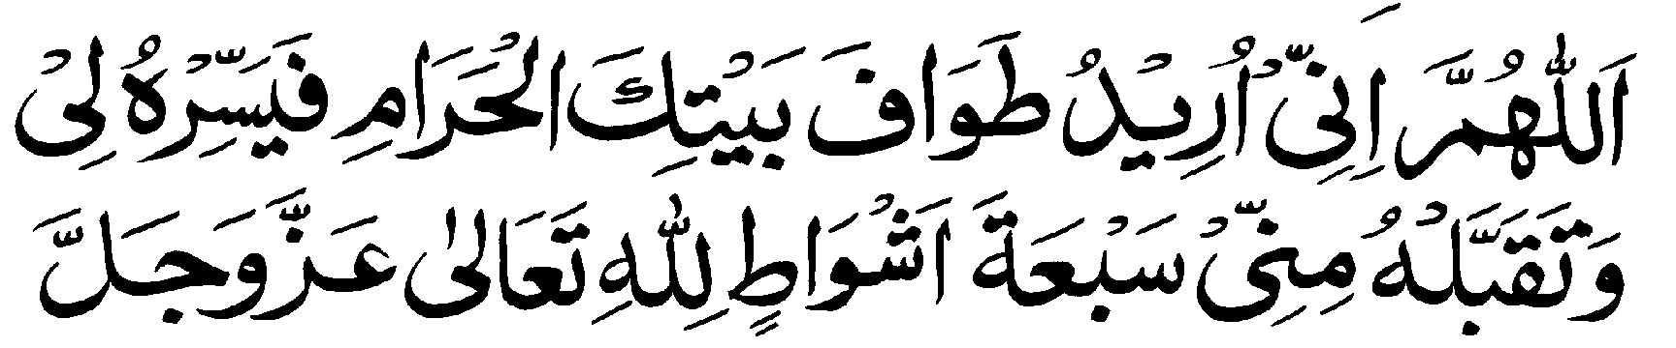
- Standing in this position near the strip, stop reciting Talbiyah and express your intent (Niyah) of performing Tawaf. Invocation or Niyah of Tawaf.

- If one failed to declare intent loudly but set in by heart, that will also be enough. Stop saying Talbiyah.
- Now step on brown/white strip, facing Ka`abah.
- Your chest is now in front of Black Stone.

- Now stretch your hands with palms facing the Ka`abah. Then raise your hands upto ears saying . Put down your hands. Stretch your hands again, upto chest level, both palms facing the Black Stone. (This act is called Istilam of Black Stone). Kiss your palms. Saying
- Start the Tawaf (circling the Ka`abah) keeping the House on your left. Men with right shoulder open shall begin the circling with a brisk speed. This condition does not apply on women.
- Keep on moving around Ka`abah including Hateem till you reach Rukun-e-Yami (the Yamani corner).
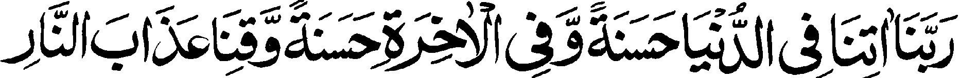
- From the Yamani corner to Black Stone recite in full till you reach the brown / white strip. This completes one circle around Ka`abah. Repeat Istilam for second circuit. However the feet and chest will not face the Ka`abah. Only the face is allowed to be turned towards the House and with hands stretched and palms facing Black Stone. Kiss the palm and begin to move for second circuit reciting . Ramal i.e. the bnisk walk is required in first three circles. At the end of seventh circuit perform the Istilam once again. This will be eight in count. Tawaf is now over and one can cover his right shoulder.

Multazim
The portion of wall of Ka`abah between the Black Stone and the door of Ka`aba is known as “Multazim”. It is said that all your invocations / prayers said here are given acceptance by God. Here one is required to embrace it, touch it with hands and body and seek forgiveness from Allah. It is reported that Prophet Muhammad (PBUH) used to embrace Multazim, like a child embraces his mother, kiss it frantically and pray with all humility and concentration. However while in Ihram, one should not try to embrace it, as often it is found to be smeared with scent. Instead one should confine to invocation. It is always crowded with pilgrims, making it difficult for weaker ones to reach and touch. Such pilgrims may stay in front and pray.

Zam-Zam Water
Zam-Zam water is very healthy and digestive. It is a cure to many diseases. It is abundantly available in the Holy Mosque. Drink it as much as you can, say الله بسم at each beginning and drink it in standing posture, with three pauses in between. After every drink say الحمد لله Pray after drinking Zam-Zam water facing Ka`aba in the following words: -
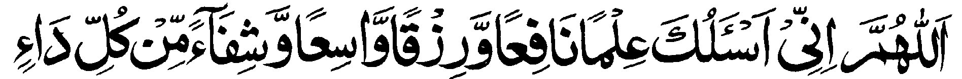

Two Unit Salat after Tawaf
Offer two units (Rakat) of optional prayer after the completion of Tawaf in salutation to it. This optional prayer is offered keeping the Muqam-e-Ibrahim in front, not necessarily close to it. It can be at any convenient place but Muqam-e-Ibrahim should be in front.
- Offering two unit optional prayer, with Ibrahim`s place (Muqam-e-Ibrahim) in front is compulsory after every Tawaf.
- These two units optional prayer should be offered at the earliest. It should not be delayed except in two prohibited intervals.
- If one performed Tawaf after the afternoon (Asar) prayer, then he should wait for sunset and evening (Maghrib) prayer. After offering the three units of obligatory evening prayer he should offer the salutary prayer of Tawaf before the usual sunnah and optional prayers of Maghrib. Likewise if one performed Tawaf after the early morning (Fajr) prayer, he should wait for sunrise to offer the prayer after that of Tawaf.
- If one performed more than one Tawaf, one after the other, but did not offered the salutary prayer after each Tawaf he will have to offer two units of salat for each Tawaf separately.

Saeey
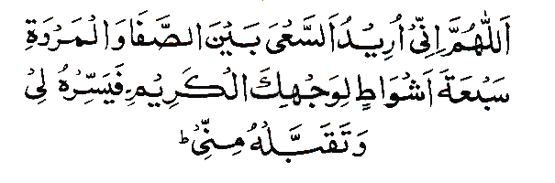
Having said the two units optional prayer after Tawaf, one should again return to brown/white strip drawn from Black Stone and perform ninth Istilam before moving towards As-Safa hillock. Standing on As-Safa hillock, facing Ka`aba one should declare the intent of Saeey with the following prayer: -




Having said the formula prayer of Saeey say three times followed by one time “Kalma-e-Tauheed”, Darood Shreef with piety and emotions. This is one of sacred moments of the acceptance of your prayer. Then recite the following invocation: - then say , climb down from As-Safa and start walking towards Al-Marwah reciting any of the prayer/invocation or the third Kalma. There is a small length between the two hillocks identified by green lights. Here the pilgrim has to run (men only) to repeat the tradition of Hazrat Hajra (A.H) reciting:
Coming out of the green marked length, one can walk to Al-Marwah. This completes one round of Saeey. Walk now towards the As-Safa for the second round. Every pilgrim has to walk and run (in the marked space) seven times between As-Safa and Al-Marwah reciting any prayer/invocation that one remembers. Each time when one reaches Safa or Marwah, he has to say the formula prayer of Saeey.

Issues Related with Saeey
- For every pilgrim who is performing Umrah, Saee is an obligatory/duty but it has to follow the circling around Ka`aba (Tawaf). Without Tawaf Saeey has no meaning.
- In an state of mensuration for ladies or in any other obstruction, it is not binding to go all the seven rounds between As-Safa and Al-Marwah in one go. One can walk in procession for seven rounds at different times. No immolation shall fall due except that one can not shave his head or cut hairs symbolically to come out of Ehram till he has walked all seven times.
- Saeey can be performed even without ablution.
- Use of wheelchair without genuine disability is prohibited. A healthy person, without any disability, shall have to repeat the Saeey, if he had earlier performed it on wheelchair. Otherwise he shall have to perform immolation of an animal.
- Saeey is an obligatory part of Umrah and Hajj only. There is no optional Saeey.
- Some people while at As-Safa or Al-Marwah, raise their hands upto ears with palms facing Ka`aba. This way of pointing is not correct. The correct way is to raise the hands as if for invocation (Dua)
- Some people run all the way from As-Safa to Al-Marwa. This is not correct. One has to run only in the specified passage identified by green lights.

Halaq and Qasar
After the completion of Saeey, one can come out of Ihram after: -
- Completely shaving his head (known as Halaq) or
- Cutting one forth of hairs (known as Qasar). Ladies shall have to symbolically cut their hairs equal to about one finger length.

Rules of Halaq & Qasar
- For men it is preferable to shave their full head (Halaq)
- There is no harm in trimming one fourth of hairs (Qasar) but if the hairs are so small and thin that one fourth can not be attained, then one should get his head shaved.
- After each Umrah, one is bound to get his head shaved, before coming out of Ihram restrictions, irrespective of the growth of hairs.
- Those who perform Umrah, even daily, they too shall have to get their head shaved after every Saeey.
- It is not necessary to have grown up hair for shaving to come out of the Ihram. Those who cut part of their hairs after first Umrah and then follow another part for second or third or fourth Umrah, it is bad and disapproved (Makrooh)
- To come out the Ehram, Qasar or Halaq is to be carried out within the limits of Haram. It one got his head shaved outside the limits of Haram, immolation (Dam) shall fall due in this condition. But if one went out of the limits of Haram in Ihram for some specific purpose and returned back for head shave, there is no harm or compensation as he was still in Ihram .
- It is not necessary to shave the head immediately after Saeey. There is no harm if it is delayed except that one can not come out of Ihram before head shave and shall have to observe the restrictions of Ihram. After performing Umrah, one should say two units of optional prayer as of thanksgiving and doll out some money.

Taneem
Taneem is Meeqat for those living in Makkah. All those pilgrims who wish to perform another Umrah should go to Taneem to don the Ehram and say optional prayer in Masjid-e-Aisha and declare his intent (Niyah) for Umrah. This exercise shall have to be repeated for each Umrah.
It is reported that Prophet Muhammad (PBUH) sent Hazarat Aisha (RDA) with her brother Abdul Rahman bin Abu Bakar to Taneem, which is out side the limit of Haram, to put on the Ehram. She performed Umrah after donning Ehram at Taneem. There is a mosque here known as Masjid-e-Aisha. It is preferable for those living or staying in Makkah or within the limits of Haram to don Ehram at this Meeqat.

Invocations in Tawaf
Tawaf (circling around Ka`aba) is itself a great prayer with reward. But this reward is excelled or enhanced when the pilgrims pray with the depth of his heart and absolute concentration.
Recitation of third Kalma is the most recommended prayer. While walking between Yamani corner and the Black Stone one should recite . Besides this one can recite any prayer and invocate.
As matter of fact each circle around the Ka`aba has its own (Dua) prayer but one can recite any other prayer (Dua) that is brief. One can also pray in his own language understanding the sense of what he is uttering. God the merciful listens the prayer of his creature. Language is no restriction.

Some Useful Invocations
There are numerous invocations and prayers given below that one can recite. All are directed towards seeking forgiveness.

- It is reported that the Holy Prophet (PBUH) used to say this prayer whenever he get up in the night.

- This is to come for in protection of God for those who are mislead and ignorant.


- This prayer is important in seeking salvation.


- The Holy Prophet (PBUH) said this prayer while digging the trenches. One should recite this prayer one hundred times in Arafat.


- This invocation is associated with Moses (PBUH) and relieves us from poverty.

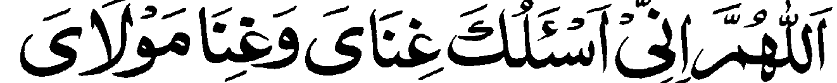
- The Holy Prophet (PBUH) recommended this comprehensive prayer for self and relatives.


- The Holy Prophet (PBUH) sought God’s help while describing his weakness.


- Moses (A.S) sought deliverance from cruel and unjust people.


- Prophet Muhammad (PBUH) was guided to say this prayer. O` God, forgive me. Have mercy and You are the greatest among those who show mercy.

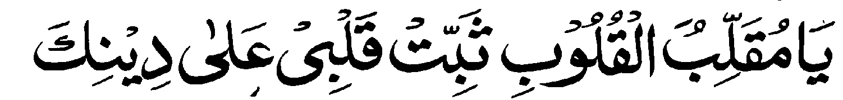
- The Holy Prophet (PBUH) ordained that it is the best prayer for remaining firm and holding fast on your faith.


- O God, keep me on the right path and reward me with piety. The invocation is so significant that Hajis are directed to say this prayer in Arafat at least one hundred times.

- This prayer relieves one from any amount of sins. It seeks forgiveness from God, repentance, and unity of God. It is recommended that besides reciting it in Tawaf, one should repeat this prayer every morning and evening and also in Arafat (hundred times on rosary)
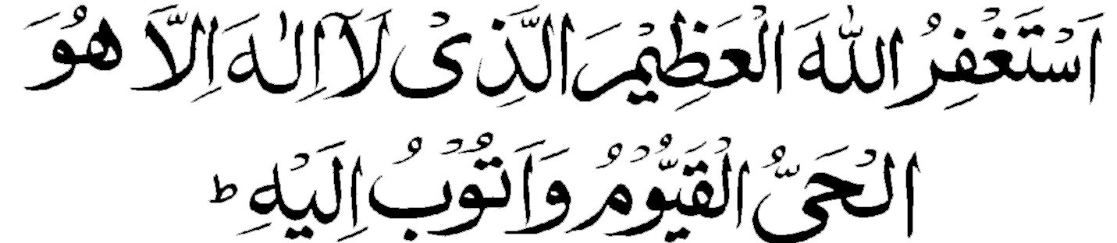

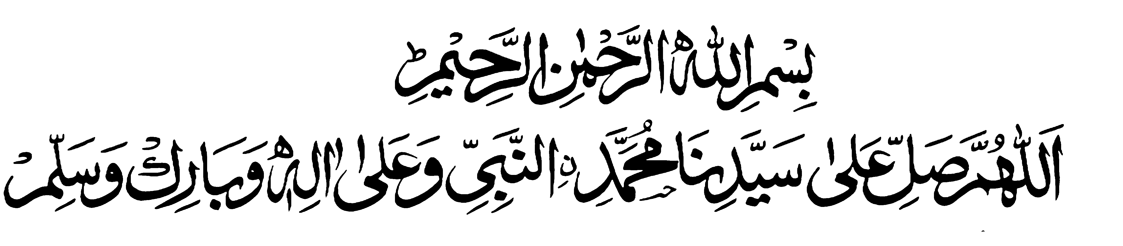
The Hajj

The five days of Hajj are:
8th, 9th, 10th, 11th and 12th ZilHijj

The rites of Greater Pilgrimage
- The first day of Hajj; 8th ZilHajj: All pilgrims depart from Mak`kah, after the Morning Prayer for Mina. In Mina, the pilgrims have to offer the Noon prayer (Zuhur) to Night prayer (Esha) and stay there overnight.
- The second day of Hajj; 9th ZilHajj: All pilgrims after offering the Morning Prayer depart for Arafat. They have to offer Mid-Day and afternoon prayers in Arafat, combined or separately. Waqoof (standing) in the plain of Arafat is the most important rite of Hajj after the afternoon prayer. Pilgrims depart from Arafat after the sunset is announced by loud bang. The combined evening and night prayers are offered in Muzdalfa. Seventy pebbles are also collected in Muzdalfa for lapidation of the Satans in Mina. Stay in Muzdalfa for the whole night.
- The third day of Hajj; 10th ZilHajj: Morning prayer in Muzdalfa standing (Waqoof) before dawn and saying worshiping prayer. Departure for Mina a little before dawn. Arrival at Mina. Then hurling seven pebbles at Great Pillar (symbolizing Satan). Immolation of a head of livestock (goat or ram). Shaving of head by men and symbolic cutting of hairs by ladies. Coming out of Ehram and putting on usual cloths. Going to Mak`kah to perform Tawaf-e-Ifada (Ziarat) with Saeey (if not done earlier). Return back to Mina for overnight stay.
- Fourth day of Hajj; 11th ZilHijj: Lapidation (Hurling pebbles) on three pillars after mid-day. The lapidarian in to begin from small to middle and then to greater Satan. Stay at Mina for the night.
- Fifth day of Hajj; 12th ZilHijj: Lapidation of three Satan after mid-day in the same order as on fourth day i.e. from small to middle and to greater Satan. This lapidation is to be accomplished before sunset. If Tawaf-e-Ifada (Ziarat) has not been performed as yet, it has to be done positively before sunset. End of stay at Mina. End of pilgrimage.

The three Pillars of Hajj
- Donning of Ihram with declaration of intent (Niyah) with all sincerity and from the depth of heart. It is considered as the most essential ingredient in individual’s commitment to make the pilgrimage.
- Standing (Waqoof) in Arafat. It is an essential and core rite of the Hajj, if the pilgrimage is to be made valid. The standing can be done from the mid-day of 9th ZilHijj to a little before dawn on 10th ZilHijj. But normally it has to be accomplished in Arafat between mid-day and before sunset. Even a brief standing in the plain of Arafat makes the pilgrimage valid.
- Tawaf-e-Ifadah (Ziarat). It is the circumambulation (Tawaf) of Ka`aba with Saeey after the lapidation, immolation, shaving the head at Mina on 10th ZilHijj when Ihram restrictions are removed. This can be accomplished from 10th Zilhijj to 12th Zilhijj (before the sunset). If any of these three obligatory rites is missed or omitted the pilgrimage shall not be valid. Neither can it be compensated through any immolation (Dum).

Duties (Al-Wajib) of Hajj
- Standing (Waqoof) at dawn in Muzdalfa.
- Walking in procession (Saeey) between As-Safa and Al-Marwah.
- Lapidation (hurtling) of pebbles on three pillars symbolizing Satan.
- Immolation (sacrifice of animal) by those performing Hajj-e-Tamattu or Qiran.
- Complete or partial shaving of head by men and symbolic cutting of hairs by women.
- Farewell Tawaf by all those coming from outside the limits of Haram i.e. far off.

How to perform Hajj
(Rules and Etiquettes)
8th ZilHijj (First day of Hajj): Days from 8th ZilHijj to 12th Zilhijj are known as the “Hajj Days”. These days are the most sacred and venerated of the entire pilgrimage. 8th of Zilhijj begins after the evening prayer (Maghrib) of 7th Zilhijj. The pilgrims should make the necessary preparations to proceed to Mina. They can even move in the night in view of heavy traffic and congestion on road these days.
If one has donned Ihram with intent of Qiran or Ifrad it is good. For those having the intention of Hajj-e-Tamattu, donning of a fresh Ihram is necessary in the same manner as for Umrah. However while uttering the intent (Niyah) one shall say Hajj in informal invocation. If one is substituting some one, call his name in full
Intent (Niyah): - O` God I declare my intention of performing Hajj in total submission of myself to You, to seek Your forgiveness and blessings. Make it easy for me.
Keep on praying the Talbiyah while travelling towards Mina. Avoid as much as you can in indulging into worldly matters and talking. Bear with patience if there is any difficulty or problem. This is your hour of test.
One has to offer five prayers in Mina as ordained by Prophet Muhammad (PBUH). Stay at Mina in the night of 9th Zilhijj is a Sunnah that need to be observed.

THE DAY OF ARAFAH
9th Zilhijj (2nd Day of Hajj)
Also (Days of Tashriq: 9th To 13th ZilHijj)
Departure for Arafat: - Offer the early morning prayer in Mina, recite the formula prayer of Tashriq, say Talbiyah and start moving to Arafat. In Arafat, the most essential and most blissful act is to stand in prayer (Waqoof). The time of Waqoof starts after midday prayer and lasts till a little before the dawn of 10th ZilHijj but as normal practice Hajis should depart from Arafat on the sunset (Maghrib). However if a pilgrim, due to some reason reaches Arafat even after Maghrib his Waqoof is accepted. While standing (Waqoof) seek forgiveness from God in as many words as you can recollect, seek His blessings for self and for your dear ones.
Offer your mid-day prayer at your place in congregation if you can not reach the Nimrah mosque then stand in prayer (Waqoof).

How to offer Mid-Day and Afternoon Prayer in Arafat
- The joint prayer of Mid-Day and Afternoon in Arafat is not obligatory (Wajib). It is only Sunnah. For a joint prayer, it is necessary that the prayer leader should be a non-resident like other pilgrims. It is usually arranged in Nimarah mosque by calling the prayer leader from outside Mak`kah by the govt. The joint prayer of mid-day and afternoon is offered with one prayer call (Azam) and two announcements (Takbir) for the initiation of the prayers. First two units of curtailed prayer (Qasr) of mid-day is offered followed by two units of afternoon prayer (Qasr). No sunnats are to be offered after the afternoon prayer (as per rule.).
- If the pilgrims are staying at their places, they should offer the mid-day and afternoon prayer at the appointed times individually or in congregation.

The Excellence of Arafat
It is reported that Prophet Muhammad (PBUH) prayed for Hajis: - “O God, accept him in salvation and to those for whom he prays. The Prophet Muhammad (PBUH) repeated his prayer for three times.

Total Salvation
- There is no other day better than the day of Arafah when God the all Merciful forgive his creature and save them from the fire of hell. God Himself come nearer to his slaves (world) then asks with prides what my creatures want.
- It is reported by the Prophet (PBUH) in an Hadith: - “that God, the Almighty and most Benevolent, welcomes those in Arafat. These are my obedient bondsmen having come disheveled to seek my blessing. Then He addresses His men and women; ‘Whatever and any amount of sin you have committed have been forgiven. You can go to your homes in peace and tranquility.”
- It is reported that one is most sinner who stood in Arafat yet think that God has not forgiven him. (Masnad-e-Alfirdous)
- If the day of Arafat falls on Friday, the day is more blessed.
- It is stated that except the day when Battle of Badar took place, it is the day of Arafah when Satan is humiliated and feel angry because Allah showers His blessings in abundance on those present in Arafat and forgive His servants of sins of any magnitude.
- Prophet Muhammad (PBUH) prayed profoundly in Arafat for the salvation of his Ummah God the Merciful accepted his prayer and declared to have forgiven all the sins committed by your followers. However the cruel and tyrants shall not be spared and have to face the revenge. The Holy Prophet (PBUH) further prayed for the salvation of even the cruels, God in His Mercy can reward the one who has suffered at the hands of tyrant and forgive the cruel.
- On the next the morning in Muzdalfa, God the most merciful accepted the prayer of his beloved Prophet. When the companions saw the Prophet in smile, they dared to ask for his smile. The Prophet replied that God has accepted my prayer and plea to excuse even the tyrants. However, Satan is in despair and very angry, crying since his wicked moves have failed.

Invocations and Prayers in Arafat

- It is reported in an Hadith that a Muslim who enters the plain of Arafat even as late as evening and recites “Kalma-e-Tauheed one hundred times facing the Ka`aba.
- Surat-ul-Ikhlas one hundred times and Darood also one hundred times; God in His Mercy will forgive all his sins and tell the angels to be witness thereof since he acknowledged My Magnificence (an attribute of God), praised me and offered Darood for my beloved Prophet Muhammad (PBUH). If this man demands the forgiveness of all those present in Arafat. I will accept his prayer too.
The Holy Prophet (PBUH) ordained the believers to recite as much as they can while in Arafat.
As further invocation, the pilgrim should recite the following: -
- Talbiyah: - One Hundred times
- Surah Ikhlas: One Hundred times
- Darood-e-Ibrahimi: - One Hundred times
- Istighfar: - One Hundred times
- All the four Kalmas: - One Hundred times each.

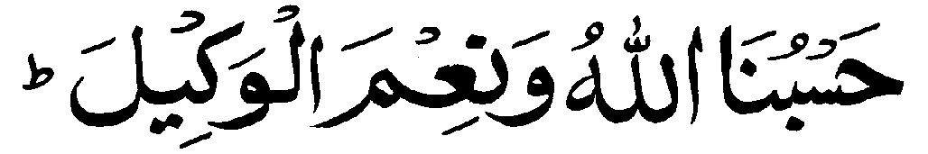
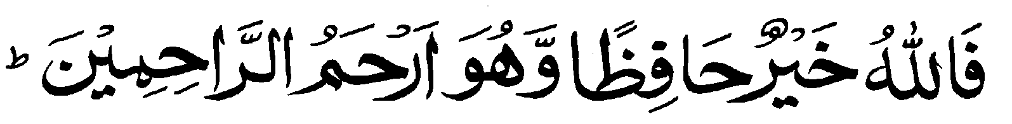
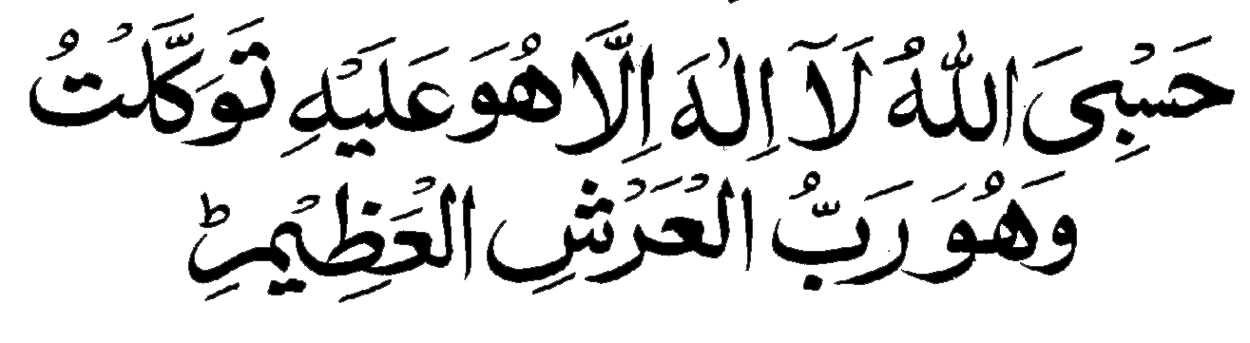

- Yaseen: - One time
- Sura-e-Malik: - One time

The Holy Prophet (PBUH) too recited this invocation too, while in Arafat.

Rules and Etiquette of Waqoof
- Talbiyah, Takbeer, Invocation, Repentance, Recitation of Holy Quran, Darood-e-Sharif are the order and requirements of this day with resolution and faith that God the Merciful shall listen to the prayers and cries of his servants and forgives their sins.
- Pray with all humility and concentration of head and heart.
- Waqoof has the meaning of standing in Arafat, facing the Qibla (the house of God. It can be individually as well as collectively. If feel tired one can sit or lie down on ground.
- While praying in invocation raise your hands towards the sky as one does after every Salat. It is desirable (Mustahab)
- It is preferred to stand in open even if there is sunshine. Yet if there is any hindrance on any pretext, standing in shade is also permitted.
- During the time of Waqoof it is desirable to feed the poor, distribute alms, help those in need and do all the good deeds.

Waqoof in Arafat
Arafat is a sandy and undulated plain. It is inhabited but every year on 9th of Zilhijj it finds over many millions of human all in same type of white shroud like cloths camping here.
The Waqoof or Standing time in Arafat starts after mid-day prayer. Pilgrims should finish their lunch and mid-day prayer and get busy in Waqoof and invocation. The time of Waqoof in Arafat ends at sunset.
The Holy Prophet (PBUH) prayed here extensively for the salvation of his Ummah, the Muslims.
The pilgrims should stand in attention and respectably as if standing in front of Lord, their Creator Allah the Most Benevolent with all their humility.
Seek his benevolence and bounty weepingly from One who is the most forgiving. These are the moments when God has opened the doors of His treasures for his creature. This is the most precious time of one’s life as you are as near to God like the one is in his lap. Ask whatever you want. You may not get another opportunity of this value.

Afternoon in Arafat (Asar)
As the time of afternoon (Asr) prayer approach, concentrate as much as you can in invocation and seeking salvation. “God the Merciful is listening your prayers and calls repentance, renunciations and answer them”. The pilgrims should rest their faith that their calls and prayers have been accepted. God the Merciful shall not let them go empty handed.
Offer the afternoon prayer at your place and make yourself ready for departure to Muzdalfa. Say Takbir-e-Tashriq. A signal is usually fired by the authorities to announce that it is time to depart.

Departure for Muzdalfa
As the sum sets in Arafat, the pilgrims should leave for Muzdalfa. In Muzdalfa all the pilgrims have to offer Evening and Night prayer,jointly,followed by an over night stay here in open. The halt in Muzdalfa by the pilgrims is prescribed in Quran.
“When you depart from Arafat, invoke God close to Mash`ar al Haram (sacred Monuments). Invoke Him for He has set you on the right path, though you had gone astray before”.
On reaching Muzdalfa, the pilgrims shall offer the Maghrib (evening) and Night (Isha) prayer jointly in abbreviated from in accordance to the dispensation granted to the travelers. First it will be three units (Rakat) of evening prayer followed by two units of Night prayer.
It is the most sacred night among all nights of year. One may ask for anything from God and He will be pleased to grant you in His benevolence. God is very happy and pleased with his creatures and servants.
There is no prohibition of lying down or sleeping here but this short spell of night is of immense importance and no one would like to miss this life time opportunity of prayer and invocation. Here the pilgrims have to stay in open.
The pilgrims also have to collect forty-nine or seventy babbles for stoning the three Satans in Mina.
The pilgrims shall leave Muzdalfa for Mina the next morning, just before sunrise after offering the dawn prayer and standing (Waqoof) for some time before the sacred monument. Waqoof (standing) is obligatory (Wajib) in Muzdalfa and one who missed it will have to give penalty of sacrificing an animal (Dum).
However, people of advanced age, sick or weak, if they can not sustain the hastle of the milling crowd can go to Mina even in the night.
While offering the abbreviated prayers of Evening and Nightfall at Muzdalfa congregation is not essential. It can be equally offered individually. The two prayers are offered with one call and one Takbir. After the Isha prayer (abbreviated) one should offer the remaining portions of the two prayers including the “Witar”.

10th ZilHijj – (3rd day of Hajj)
10th ZilHijj is a very busy day among the Hajj rites. Each pilgrim has to perform several obligatory, essential and optional duties.
First Duty
Standing (Waqoof) in Muzdalfa
In Muzdalfa, just after the morning prayer, stand for a few minutes facing in the direction of Ka`aba. The time available is very short as it ends a few minutes before sunrise. Invoke the bounty of God, pray and seek forgiveness for yourself.
Second Duty
Lapidation(stoning) of Jamrat -l-Aqabah (The greater Satan)
As the pilgrims travel back to Mina, their first duty is the stoning (Lapidation) of Jamarah-al-Aqabah (the greater Satan). The act is called “Rami” in which the pilgrim has to hurl seven pebbles one by one, striking the pillar; uttering الله اكبر “God is great. There is no other God but God”. Stop the recitation of Talbiyah before lapidation and abstain from saying any other prayer or word in accordance with the tradition or making any other invocation.
On 10th ZilHijj, the time of Rami begins after sunrise and ends a little before the sunrise of next morning i.e. 11th ZilHijj. Should a pilgrim fails, for any reason to perform all or a part of Rami (the stoning of Satan) he must atone for it by sacrificing an animal or fasting.
The Rami of Jamarat on 10th, 11th and 12th day of ZilHijj are compulsory. Yet those who stay in Mina on 13th ZilHijj, they shall have to stone the Jamarat on this day too.

Third Duty
Immolation (sacrifice) of the animal
“It is not the meat (of the sacrificial animal) that reaches God neither their blood; it is your piety that reaches Him”. (Al-Quran; 22:37)
Having finished the Rami (Stoning) of greater Satan, every pilgrim is duty bound to sacrifice a head of livestock. It can be goat, sheep or even a camel in participation. This sacrifice is to perpetrate the memory of great sacrifice of Abraham (PBUH), the great forefather of Muslims. Hundreds of thousands of Muslims from the four corners of the world who gather in Mina on this 10th day of ZilHijj celebrate the “Feast of Sacrifice” also known as “Eid-ul-Adha”. Animal sacrifice is not obligatory or desirable for those who are performing Hajj of Ifrad class. Yet he can do so if he wishes.
The next rite after the sacrifice of the animal is the head shaving for men also call “Halaq”.
One important thing to be noted here is that the sequence of rites is to be maintained at any cost. It can not and should not be altered. The sequence is
- Rami of greater Satan
- Sacrifice of the animal
- Shaving of head by men and symbolic cut of hairs by women.
- Those performing Hajj under the vow of Qiran or Tamattu, animal sacrifice is obligatory. This sacrifice besides being in memory of the sacrifice of Hazrat Ibrahim and a tradition of Prophet of Islam (PBUH), is also a thanksgiving.
- The rules for this sacrifice on 10th ZilHijj are the same as for other sacrifices.
- Seven persons can share in sacrifice of a camel, cow or oxen. But each one should have the same intention of sacrifice. If any one bears some other intention the sacrifice of all others shall become void.
- Animal sacrifice can be done on 11th and 12th ZilHijj too, besides 10th ZilHijj but maintaining the sequence of rites is compulsory.
- Animal sacrifice is to be performed within the boundaries of Haram.
- In addition to the obligatory animal sacrifice by every pilgrim, the animal sacrifice is equally obligatory on those who pay Zakat or have the means. There is, however, no restriction of place of this second type of sacrifice. It can be carried out in Mina or at the hometown.
- If a pilgrim is not capable of animal sacrifice of Hajj, he should observe fast on 7th, 8th and 9th ZilHijj and seven fasts after the days of Tashreeq. The seven later fasts can be anywhere i.e. in Mak`kah, Madina or back at home but in continuation.
- If after having fasts for three days, a pilgrim becomes capable of immolation before head shaving, he will have to offer animal sacrifice. His fasts shall become void.
- The three fasts of 7th, 8th and 9th ZilHijj are to be in continuation. If one or two fasts are missed, the pilgrim shall have to sacrifice the animal and his two or one fast shall be deemed to be lost. It may be noted that if one skips this thanksgiving immolation (sacrifice) his Hajj shall remain incomplete. He shall be under religious sanction till such time he does not offer the animal sacrifice and that too in Mak`kah.
- If one is not in a position of animal sacrifice of thanksgiving, he can shave his head to attain legitimacy but two immolation (Dum) shall become due on him. One of Hajj and second of shaving of head before animal sacrifice.
A similar condition shall be applicable on those performing who are performing Hajj in Qiran mode. One immolation of not sacrificing animal after Rami and of shaving head and other immolation, as normal in case of Hajj Qiran.
- If one attains the position of thanksgiving sacrifice after keeping the three fasts or in between, he shall be bound to offer thanksgiving sacrifice without which he will not attain the religious legitimacy (Halal)
- For observing the three fasts as atonement (Kaffara) it is necessary to say the word Tamattu or Qiran while declaring the intention of fast.

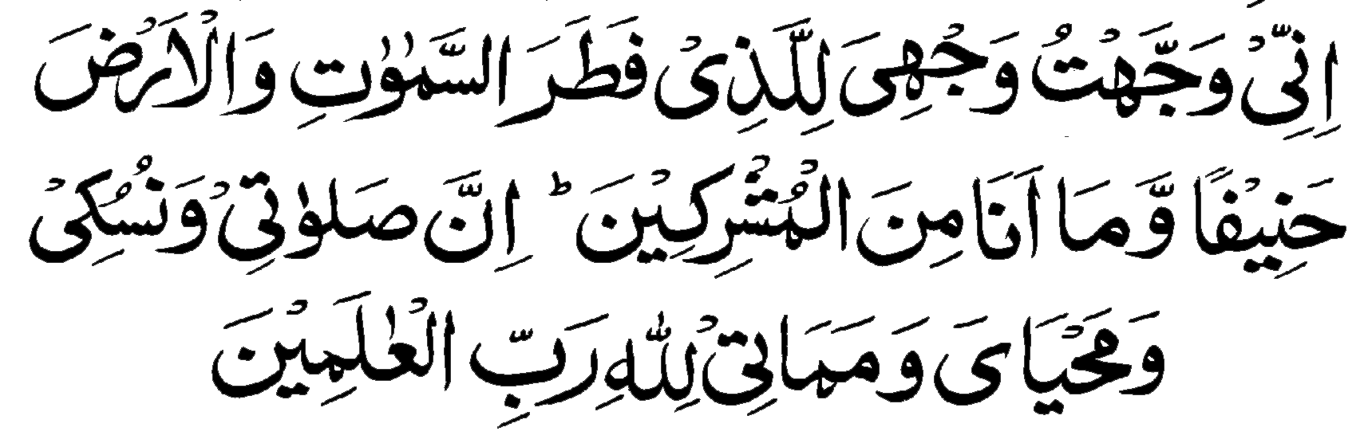
Invocation for Animal Sacrifice

Having said the invocation, recite “Bismillah” “Allah-o-Akbar” and then cut the animal.

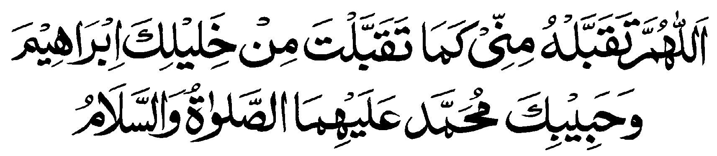
And After Immolation
Say the following Invocation

10th ZilHijj (Continued)
Fourth Obligatory Duty (Shaving of Head)
After performing the immolation (animal sacrifice) men pilgrims should get their heads shaved. They can even get their hairs trimmed or cut to an extent of one fourth. This cutting of one fourth of hairs is known as “Qasr”. It is however, preferable to completely shave the head known more so as “Halaq”.
Women pilgrims also should cut their hairs to an extent of 2 inches or equal to a length that can wrap their middle finger.
After the Halaq or Qasr the pilgrims can come out of Ehram to wear their normal dress.

More About Halaq or Qasr
After performing these acts on 10th ZilHijj ie Rami, Immolation and shaving of head, the pilgrim can take bath, come out of Ehram and its restriction, can wear his usual dress. All restrictions have now been removed. However, emotional or sexual relations are still prohibited till one perform the Tawaf-e-Ifadah (Tawaf-e-Ziarat)
In case a pilgrim performs Tawaf-e-Ifadah while in Ehram before shaving of head, the restrictions of Ehram shall continue till he shaves his head.

Time Limit of Halaq
The time to shave off the head (Halaq or Qasr) starts after stoning the greater Satan (Rami of Jamarat-ul-Aqba), followed by immolation, and lasts till the sunset of 12th ZilHijj.
The Holy Quran says: -
“That they may witness things that are of benefit to them, and mention the name of Allah on appointed days over the best of the cattle that He hath bestowed upon them. Then eat thereof and feed there with the poor unfortunate. Then let them make an end of their unkemptness and pay their vows and go and go around the ancient House”. (Al-Hajj: 28,29)

Tawaf-e-Ziarat (Tawaf-e-Ifadah)
It is an essential part (Rukun) of Hajj without which the rites of Hajj are not completed.

Rules for Tawaf-e-Ziarat
- The time of this Tawaf (circumambulation) starts after the early Morning Prayer on 10th ZilHijj and lasts till the evening of 12th ZilHijj. However, one should neither be in hurry to carry it out before the early Morning Prayer on Yaum-an-Nahr (Day of animal sacrifice) nor should delay or postpone it without reason.
- If one failed to perform Tawaf-e-Ifadah (Ziarat) he can not establish marital relations. This restriction equally applies on female pilgrims.
- Maintaining of a sequence between Tawaf-e-Ziarat on one side and Rami, immolation and Halq on other side is preferable as ordained by Holy Prophet (PBUH) but not obligatory (Wajib). If one performed Tawaf-e-Ziarat before Rami and Halaq, it is accepted but is not appreciable.

Saee After Tawaf-e-Ziarat
For those who have Vowed or opted for Tamatto formula of Hajj they have to perform Saee too after Tawaf-e-Ifadah and two units of thanksgiving prayer of Tawaf. Having performed Saee between Al-Safa and Marwa hillocks and thanks giving prayer the Hajj rites have completed. Pilgrims are now free from all religious restrictions but they have to go back to Mina for an overnight stay on 11th and 12th ZilHijj.
The Holy Quran says: -
“Remember Allah through the appointed days. Those who hasteneth (His departure) by two days, it is no sin for him; and those who delayeth it is no sin for him that is for him who wardeth off (evil). Be careful of your duty to Allah and know that unto Him ye will be gathered.” (Al-Baqrah; 203)
During days of Tashriq one can return to Mak`kah from Mina on 12th or 13th ZilHijj. There is no restriction. There is no importance as to how many days one stayed in Mina. The significance is that of how much one prayed and remembered God and how much one read the Holy Qur’an.

11th ZilHijj (Fourth Day of Hajj)
11th, 12th and 13th ZilHijj are known as “Days of Rami” in the terminology of Hajj rites. If one could not do immolation (sacrifice) or Tawaf-e-Ziarat till now, he should do it today positively. During these three days Rami is the only worship for which pilgrims stay in Mina as ordained by the Apostle of God. Staying outside Mina like Mak`kah or at any other place is not permitted.

Rami
On 11th of ZilHijj the pilgrims has to lapidate (stoning) all the three Satan (Jamarats). The time of this Rami (stoning) begins after the mid-day and lasts upto a little before early morning prayer the next day.
The three pillars (Jamarah) symbolizing Satan are located at the center of Mina over a distance of 272 meters. The smallest of them lies at the far end of the village in the direction of Muzdalfah. It is called al-Jamara-s-Soghra or the First Pillar.
The second pillar, named al-Jamara-l-Wosta (Middle Pillar) is located 156 meters further in the direction of Mak`kah.
The third pillar called Jamarah-al-Aqabah (greater pillar) is 116 meters beyond the second one again in the direction of Makkah.
On 10th of ZilHijj, pilgrims have to stone only the last pillar (Jamara-al-Aqaba). They have to hurl seven pebbles one by one, saying, “God is great. There is no God but Allah”.
In accordance with tradition, they will abstain from saying any other word or making any other invocation.
On 11th ZilHijj the pilgrims has to stone all the three pillars beginning from small to Middle and then the Greater pillar with seven pebbles on each pillar.

12th ZilHijj (Fifth Day of Hajj)
If one has not yet done the immolation (the animal sacrifice) or Tawaf-e-Ifada (Ziarat) he should fulfill these rites today before sunset.
The principle rite of this day is the Rami of all three stones in the same manner as on 11th ZilHijj. The Rami of 12th ZilHijj is also carried out after mid-day and upto a little before early Morning prayer the next day.
The stoning of the pillars commemorates the Prophet Ibrahim`s gesture when he hurled stones on Satan on three occasions at these spots. It symbolizes the commitment of the pilgrims to the principle of resisting future temptations. It is regarded as the duty by all four major theological schools of Islam.
After the Rami on 12th ZilHijj the pilgrims are at liberty either to stay in Mina or to return to Mak`kah. If they do not intend to stay in Mina any more after the Rami on 12th ZilHijj, they must leave before the early morning prayer time on 13th ZilHijj. If the 13th ZilHijj dawned while the pilgrims are in Mina then Rami on 13th become obligatory and if one left without performing on this Rami, he shall have to offer animal sacrifice (Dum).
Al Humdu Lillah, all the rites of Hajj has been completed with the grace of God and his blessings.

Farewell Circumambulating (Tawafye-Wida)
Tawaf-e-Wida or Farewell Tawaf is not obligatory for those living in Mak`kah but is obligatory on all other pilgrims coming from distant places. This is the last rite of the sum total performance of Hajj irrespective of one’s intent of mode of Hajj i.e. Tamattu, Qiran or Ifrad. If one has performed any optional Tawaf after Tawaf-e-Ziarat, the duty or obligation of Farewell Tawaf is fulfilled. Yet if one stays in Mak`kah for some time it is desirable to perform one or more Tawaf as farewell to the House of God. This Tawaf can be performed in one’s usual cloth not necessarily in Ihram. No Ramal is required in this Tawaf. However one should offer two-unit prayer after this Tawaf and invoke the bounty of Allah in all humiliation. Ask from God whatever you like with tears.

Prayer of Prophet Ibrahim (PBUH)
“Our Lord! And raise up in their midst a messenger from among them who shall recite unto them. Thy revelations and shall instruct them in the scripture and in wisdom and shall make them grow. Lo! Thou, only Thou, art the Mighty Wise. (Al-Baqrah: 129)
The above supplication of Prophet Ibrahim was accepted by God and He sent Muhammad (PBUH) as His Prophet with Book as blessing to his exalted creatures.
Every pilgrim feels restlessness after the Hajj to proceed to Madina as early as possible to convey his greetings and Salam to the Holy Prophet (PBUH) on whom the angles send their greeting and Darood day and night. This serene journey from Mak`kah to Madina is a journey of affection and love to the court of the noblest person among the humanity.

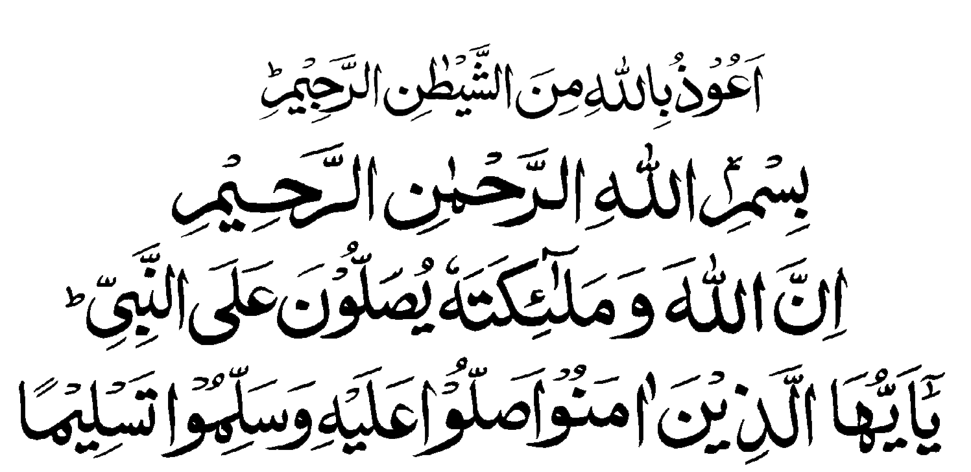

JOURNEY TO MADINA
The Guest of Prophet (PBUH)

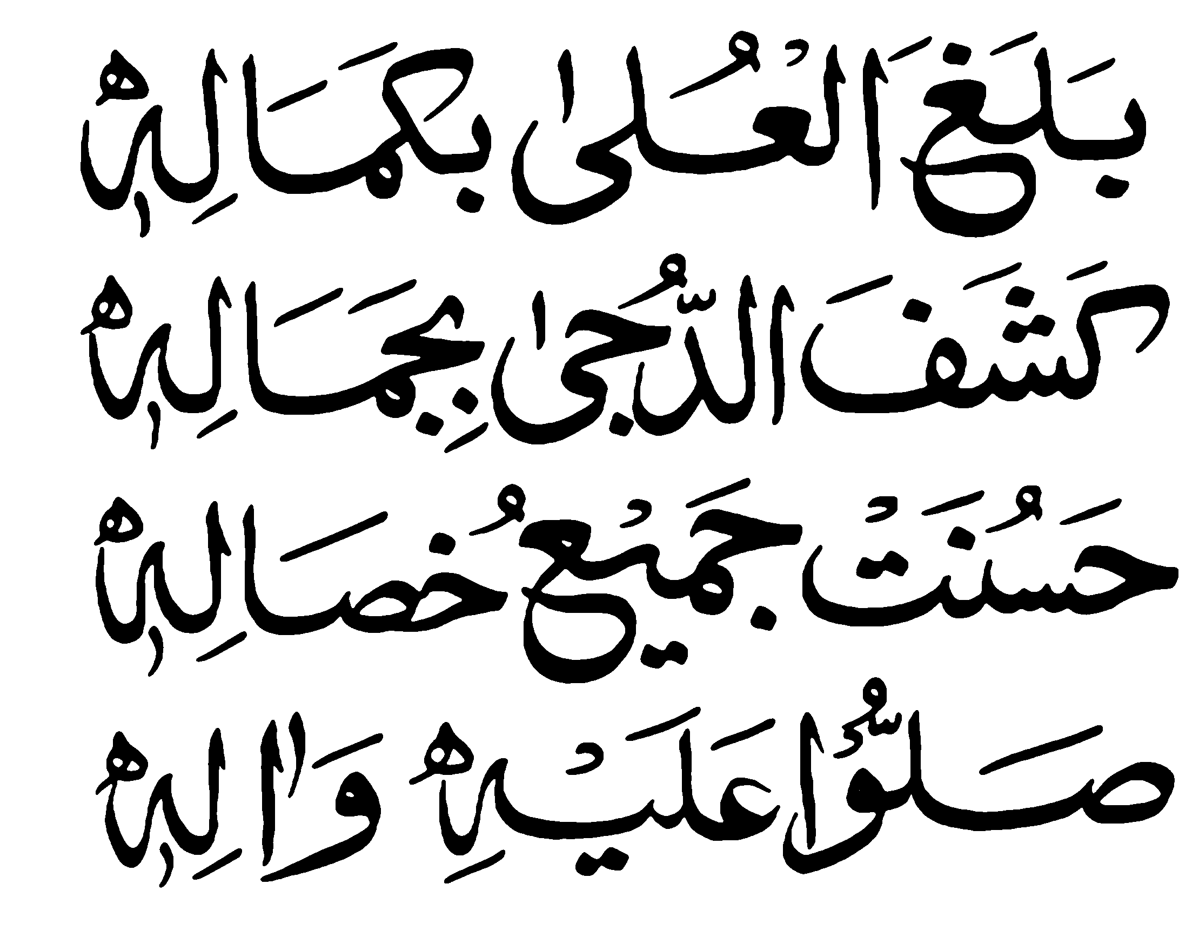

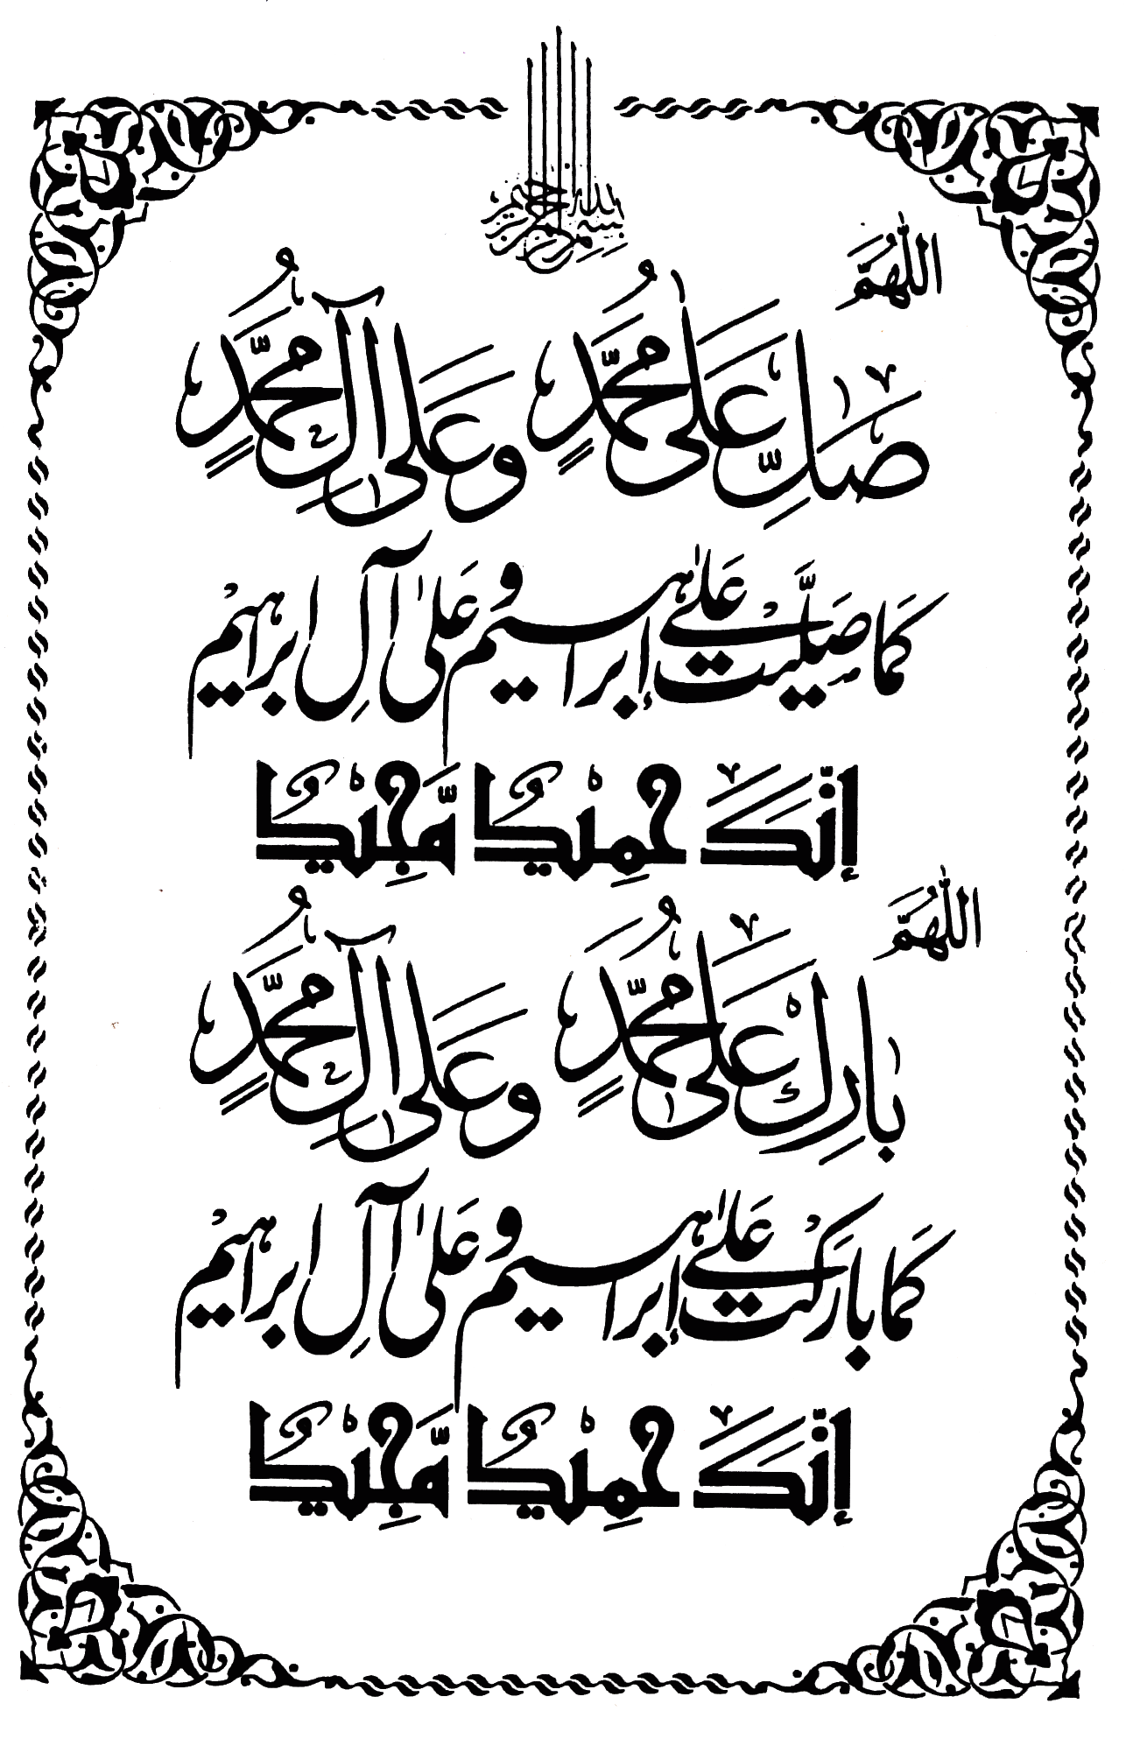

Preparation before Proceeding to Madina
With the grace and help of God the pilgrims are now in Mak`kah and have also performed Umrah. Some of the pilgrims go to Madina-tul-Munawwara before Hajj while the others after the Hajj. The movement is scheduled by concerned Muallim (The Hajj guide)
Those who proceed to Madina before Hajj are advised to carry minimum possible and only very essential items of daily use as the stay in Madina is only of 8 days. Yet they must carry a set of Ehram since while returning from Madina to Mak`kah there is a Meeqat in between and one can not pass this Meeqat without donning the Ehram or in other words one is bound to enter Mak`kah in Ehram and to perform Umrah.
Whereas those who go to Madina after the Hajj should carry all their luggage as they will not be able to come back to Mak`kah. Instead they will have to go Jeddah directly from Madina for home bound journey.

Pilgrimage of Prophet’s Tomb and its Excellence
Prophet Muhammad (PBUH) said:
“One who visited my tomb is sure to get my intercession (Shafat)”
“One who came only to visit my tomb and paid his homage is entitled to seek my Shafat (intercession)”
“One who performed Hajj and then came to my tomb is like one who had the privilage to visit me in my lifetime”
“One who visited my tomb with intention that he will be in my protection on the day of resurrection and settled down in Madina; I will be his witness and he will be in my intercession” (Shafat)
“All the Prophets are alive in their graves and offer prayer”

Not coming at the Tomb of Prophet
The Holy Prophet (PBUH) said:
“One who came to perform Hajj but failed to visit my tomb, he did injustice to me”.

The Excellence of Reciting Darood
The Holy Prophet (PBUH) said on the subject:
- “One who will say Darood for me, only once, God in His mercy shall bless him ten times. His ten sins shall be forgiven and he will be awarded ten higher status.”
- “One who offered Darood in abundance for me, he shall be close to me on the day of resurrection.”
- “One who say Darood for the Prophet is rewarded by a return Darood for him by the angels and God himself.”
- “Angels love those who offer Darood for the Prophet and their problems are solved.”
- “When a man who offered Darood with regularity and dies, the same Darood becomes a source of mercy and forgiveness for him.”
- For each one offering Darood for the Prophet Muhammad (PBUH) there is an angel who convey his Darood to Prophet in his grave.
- One saying Darood shall remain protected from Hell fire. His virtues and goodness shall be surpassing in weight.
- One who recites Darood regularly comes very close to Holy Prophet.

Not reciting Darood for Prophet: Consequence
- It is reported of Hazrat Omar Ibn-e-Al-Khatab (RDA) that your invocation / prayer remain suspended between earth and sky till one recite / offer Darood for the Prophet.
- There is an Hadith that angel Jabrail, while on third stair, cursed the one who heard / listened the name of Prophet but did not said Darood. He will be debarred from the blessings of God.
- Prophet himself said, that “if one heard my name yet did not offered Drood, he is miser/ cruel.

Where it is desirable to offer Darood
- In all prayers in sitting posture after reciting “Al-Tahyat”
- In funeral prayer after second announcement (Takbeer)
- In Friday and Eid sermons.
- After the prayer call from mosques.
- While entering or coming out of the mosque.
- On the two hillocks Al-Safa and Al-Marwah between which Saee is performed.
- Whenever and wherever the Prophet’s name is called.
- While going to market.
- After saying the Talbiyah during the performance of Hajj
- While kissing the Black Stone in Ka`abah.
- Having seen the Prophet’s mosque in Madina.
- After the recitation of Holy Quran.
- On Fridays as many times as one can say.
- While seeking salvation from God.
- At the hour of trial difficulty and worry.
- While writing the name of Holy Prophet.
- If some sin is committed, not deliberately, recitation of Darood becomes its atonement.
- While looking for the solution of a problem.
- While feeling danger.

Etiquettes of Visiting Madina
When you intend to visit Madina Munawwara, set aside all your worldly needs and thoughts and describe your intent of visiting the Holy Prophet.
Intent (Niyah)
“O God, the Beneficent, the Merciful, I intend to travel to Madina Munawwara to pay my respect to the holy Prophet (PBUH), kindly accept my prayer.”
On your way to Madina, recite Darood as much as you can in paying your respect. Be more respectful and humble, as you approach the holy city. Invocate for yourself.
Messenger of God himself said that “God has deputed a group of archangels who convey the Darood to me recited by an intending pilgrim, naming him and that he is sending his compliments and greetings.”
Likewise when an intending pilgrim reaches near to Madina, the angels approach him, welcome him with praise and pleasantries. Prophet Muhammad (PBUH) had said “that one who performed Hajj and thereafter cane to pay his homage even after my death, is just as he visited me during my lifetime.”

In Madina-al-Munawwara
Having reached Madina, the pilgrim, at first, should settle down comfortably at his place of stay. However one is required to be careful enough that nothing indignified occurs. It is the city of Holy Prophet (PBUH) most revered among the cities, next to Mak`kah. One should not criticize for any shortcoming. If anything hurts, that should be taken with grace and patience. Every nook and corner of Madina deserves your love and veneration.

Visit to Prophet’s Mosque
Take bath and dress in best one have. You are to present yourself to the man most beloved of God your master, the best human amongst the humanity.
Walk towards the mosque in most humble but in dignified way. Offer some alm, if possible. On reaching the doorsteps of the mosque remove your shoes and enter with right foot first.
Recite the prescribed invocation of entering into a mosque with Darood followed by two units (Rakat) of salutation of mosque (Eitikaf) then walk forwards Raiz-ul-Jannah.
Riaz-ul-Jannah is the space that lies between the Prophet’s tomb and his chair (Mimber). God’s Messenger himself used to say of this spot! “Between my house (now his last resting place) and my mimber lies a garden of paradise. For the faithful to recite a prayer here is tantamount to praying in a corner of Paradise. No wonder, then, that this small space is much sought after by pilgrims, all of whom want to pray there.
Sit down wherever you find the place without any hastle and offer the prayer of salutation of mosque provided it is not the disapproved (Makrooh) time. If a congregation is in progress join it.
Then proceed with utmost respect and humility, eyes gazing down, to the chamber where the Prophet’s tomb lies, reciting Bismillah and Darood. Facing the golden grill with large circular opening with back towards Qibla, offer your Salam, pray for salvation and seek intercession (Shafat) from the Prophet (PBUH) in low voice taking care that you are in front of the most revered personality of the world for which you have been cherishing the whole of your life. Do not try to look here and there. It is an act of disrespect. If there are two many people crowding this spot the visitor can offer his respect and prayer from some distance too Remember that:
“God and His angels shower blessings upon the Prophet: O ye who believe, bless him and solute him” (33:56)
The Pilgrim can convey to the Prophet (PBUH) the greeting of his and all those who have asked him to do so. Be careful that the Prophet knows that who is sending his greetings and Darood and the greetings are replied.
The pilgrim then goes over to the tomb of first Caliph Abu Bakr Al-Siddiq which is a few feet away from that of the Holy Prophet (PBUH). The pilgrim now goes over to the tomb of the second caliph, Umar Ibn-al-Khattab just next to that of Abu Bakar Siddiq where he send his greetings and solute. Before each of these tombs the pilgrim must make salutation and recall the merits of he who lies beneath.

Pillars of Blessings in Garden of Paradise
(Riaz-ul-Jannah)
There are seven pillars (Ustawanah) in Garden of Paradise. They all are known as pillars of Blessings. In the first row there are four pillars of red stones. Their names are engraved on them: -
- Pillar of Hanana: - There was a date trunk here with which the Holy Prophet (PBUH) used to take rest and deliver the sermons. When a permanent pulpit was made, it is said that the trunk wept profusely.
- Pillar of Hars: - There used to be one or other companions sit here as guard when the Holy Prophet (PBUH) be inside the residence.
- Pillar of Wafood: - Here the outside delegates used to meet the Prophet Muhammad (PBUH) and convert to Islam.
- Pillar of Abi Lababa (RDA): - Ali Lababa, a companion, has committed a mistake in Tabuk war against infidels (Gazwa-e-Tabuk). He got himself tied up with this pillar as a matter of punishment; so long the Prophet does not release him. The Prophet waited for seven days till the revelation of a Quranic verse in this respect and the acceptance of his repentance, when he was freed.
- Pillar of Sareer: - Here the Prophet used to sit in Eitikaf and retire in the night.
- Pillar of Gabriel: - Whenever the archangel Gabriel come with Quranic revelation in the garb of the compassion Dahih Kalbi (RDA), he used to sit here.
- Pillar of Aisha (RDA): - The Prophet (PBUH) told his companions that there is a spot in his mosque where to offer the prayer is of excellence. The companions searched this spot vehemently but could not succeed. It was after the death of the Prophet Muhammad (PBUH) that Hazrat Aisha (RDA) identified this spot to her nephew. Every pilgrim and visitor to the Prophet’s mosque should offer the prayer near this pillar.

Invocation
Having conveyed your Salam, respect, greeting and Darood and those of others who have asked to convey their greetings, to the most honoured, most revered personality of this world and most beloved person of God, (mercy for the entire humanity), move to a place away from the crowd where you can stay away from hastle, facing Qibla. Pray to God for your salvation. Seek inter cession from the Holy Prophet (PBUH) with respect and love. This is the rare opportunity, of cleaning the soul and purity of heart that you may get.
According to a Hadith reported in Muslim and Bukhari the reward of one prayer in the Prophet’s mosque is equal to one thousand prayers in other mosques.

Forty Prayers in Prophet’s mosque
It is reported by Imam Ahmad through Hazrat Anas-bin-Malik (RDA) that apostle of God once said that “one who offered forty ritual prayers at proper time and without discontinuity in my mosque, he will be exempted from hell.”
Pilgrims are therefore advised to devote most of their time of stay in Madina in prayer in Masjid-e-Nabvi, visiting the tomb of the Prophet as much as possible to offer the greetings, Darood and seeking his intercession (Shafat). Offer optional prayer in the garden of Paradise (Riaz-ul-Jannah), read the Holy Book, Quran and bestow it in favour of the Prophet Muhammad (PBUH).
“And if, when they had wronged themselves, they had but come into thee and asked forgiveness of Allah, and asked forgiveness of the messenger, they would have found Allah forgiving, merciful.” An-Nisa (4:64)

The Holy Places to be visited
An important and noble part of this exalted journey of Hajj is to visit Madina the city of Holy Prophet and pay one’s respect, homage and greetings to the Holy Prophet (PBUH). Besides the Prophet’s mosque, there are many more places in Madina and Mak`kah having deep associations with Prophet and early days of Islam the purpose of visiting these holy places is not tourism or any enjoyment but to recall some historical facts about Islam and spiritual guidance. Generations of Muslim faithful have flocked to Prophet’s tomb and to implore God to bless and to reward him according to his merits. A believer should firm his belief to fulfil all the obligatory deeds expected from him since in their fulfilment lies his success in this life and hereafter Remember, complete submission and obedience to Allah and His Prophet (PBUH) is absolutely essential and a pre-requisite of faith.

The Cemetery of Al-Baqee
Baqee is the cemetery of Madina. Here lies, for the eternal rest, the third Caliph Usman (RDA) the wives of the Holy Prophet (PBUH) the mothers of many believers including Aisha (RDA) the daughter Abu Bakar Siddiq (RDA), Hafsa the daughter of Hazrat Umar (RDA), the Prophet’s uncle Hazrat Abbas, Ibrahim and Rukayya the son and daughter of the Prophet, the grandson of the Prophet (PBUH) Hasan Ibn-e-Ali, the Imam Malik Ibn-e-Anas the founder of Maliki school and a host of companions of the Prophet.
The visitor is always struck by the extreme simplicity of this graveyard of Baqee. The tombs of so many heroes of Islam are marked only by small stones.

The Martyrs of Uhad
The mount of Uhad, which was described by the Prophet as one of the mounts of Paradise is, situated about 5 KM North of Madina. It was at the foot of this hill that the famous battle of Uhad between the infidels and the Muslims was fought that bears the name of Uhad.

The Quba Mosque
The mosque of Quba also known as Masjid-e-Taqwa (The Mosque of Piety) is the first mosque of Islam, outside Makkah, put up by the Prophet himself. It was at this spot that the Prophet entered Madina during the migration from Mak`kah. It was also in this mosque that prophet received the following divine revelation: -
“There is a mosque whose base was founded from the very first day upon piety; it is worthier for those who came to rise (pray) within its boundaries. Within it are men who yarn to be purified and God loves those who purify themselves (Al-Tawba 9:108)
Prayer in this mosque is looked upon as a Tradition and is worth an Umrah. The Prophet was in the habit of going there from time to time. It is preferable to visit this mosque on Saturday for prayer.

The Juma Mosque
This mosque falls in way to Quba mosque from Madina. Prophet Muhammad (PBUH) offered his first Juma prayer in this mosque after migration from Mak`kah.

The Ghamamah Mosque
This mosque is situated on South-West of Manakha. The Prophet (PBUH) used to offer Eid prayers in this mosque.

The Suqya Mosque
The Prophet (PBUH) offered the prayer in this mosque and prayed for the welfare and prosperity of the people of Madina on his way to the battle of Uhad.

The Ahzab Mosque or the Fateh Mosque
This mosque is situated on the Western edge of mount Sala. During the battle of Ahzab, a large number of infidels attacked Madina and trenches were dug. The Prophet (PBUH) prayed to God here for three days i.e. Monday, Tuesday, and Wednesday. The prayer was granted and accepted by God and Muslims came out victorious.

The Zabab Mosque
This mosque falls in the way to Uhad. During the battle of Trenches (Khandaq), the Prophet’s tent was erected at this place and he offered the prayer here.

The Qiblatain Mosque
This mosque is built on the top of a hillock in the valley of Aqeeq. The change of direction of prayer from Bait-ul-Muqdis to Mak`kah was revealed in this mosque.

The Al-Fazih Mosque
Fazih is a kind of wine extracted from Dates. It was at this place that Prophet (PBUH) and his companions sorrounded the Bani Nusair Tribe of Jews. Hazrat Abu Ayub Ansari with some people was busy in drinking when the revelation banning the wine from Islamic polity was received. The Prophet ordered to break all the wine containers. He also offered prayers here during the siege.

The Mosque of Bani Qarizah
This mosque is at a short distance from Al-Fazih mosque. Prophet stayed here during the siege of Bani Qarizah tribe of Jews.

The Bani Zafar Mosque
This mosque is on the eastern side of Jannat-ul-Baqee. Close to the mosque is the deep foot impression of Prophet’s mule. This mosque is also known as Masjid-Al-Baghlatah.

The Al-Ajaba Mosque
Here too the Prophet stayed for some time and offered the prayers.

The Al-Jeer Mosque / Sijda Mosque
The Prophet (PBUH) offered two units of optional prayer here with prostration of exceptionally long duration.

The Abee (RDA) Mosque
This mosque is adjacent to Jannat-ul-Baqee. It was actually the residence of Hazrat Abi-Bin Ka`ab. The Prophet (PBUH) used to come here frequently and offer prayer.

The Bani Haram Mosque
The Prophet (PBUH) offered prayer here too. There is a cave adjacent to this mosque where some portion of the Holy Quran was revealed upon the Prophet. During the battle of trenches (Khandaq) the Prophet rested here for eleven nights.

The Ibrahim Mosque
This mosque is situated towards the north of Bani Qariza. This is also the birthplace of Prophet’s son Ibrahim out of Prophet’s wed lock with Hazrat Maria Qibtiyah. The Prophet (PBUH) offered the prayers in this mosque too.

Return from Madinah
Your visit to Madinah is now complete. However, before you depart from Madinah offer two units of prayer of gratitude in Prophet’s mosque. Then proceed to the Prophet’s tomb to offer your farewell salam, respect and Darood. Pray for your salvation and blessings, for safe journey and your wish for another visit to Mak`kah and Madinah.

From Madina to Mak`kah / Jeddah
If one intend to have a last visit to Mak`kah then enter into Ihram for Umrah at Zulhalifa mosque, which is Meeqat for Madinites. If one is close to Hajj he can declare the intent of both Umrah and Hajj at this point. However, if there is enough time left, before Hajj, then don the Ihram for Umrah only so that you can be freed from Ihram restrictions for the time left for Hajj.
If the pilgrims are scheduled to go to Jeddah from Madinah they need not to put on Ihram. Your departure formalities shall be completed by Moallim, the Hajj guide.

The End
RASHEED AHMAD SIDDIQUI
CHAIRMAN
AL-RASHEED HAJJ & UMRA GROUP (PVT.) LTD. (4111)
PH: +92216627038
CELL #: +923332321299, +923007001801.
URL: www.alrasheedhajj.com
E-MAIL: ar@alrasheedhajj.com

